

Okta Essentials  
Lab Guide

Version 2022.03.03 (H)

Copyright 2022 Okta, Inc. All Rights Reserved.

Window captures, and dialog box sample views are the copyright of their respective owners.

Use of this user documentation is subject to the terms and conditions of the applicable End-User License Agreement.

Contact Okta, Inc @ training@okta.com

Okta Essentials  
Lab Guide

Table of Contents

Essentials Labs 1

The Company 1

Challenges 1

Organization Configurations 1

Okta User Accounts 1

Active Directory Configuration 2

Labs 3

Lab 1-1: Access Your Okta Organization and Virtual Machine (VM) 3

Sign into Okta Organization 3

Sign into Virtual Machine (VM) 3

Lab 2-1: Create Okta-sourced Users 5

Before You Start 5

Create the Okta Admin Account 5

Create the AD Admin Account 6

Create the Personal Account 6

Activate the Personal Account 7

Lab 2-2: Assign Administrative Roles 8

Assign Okta Administrative Roles Based on Job Role 8

Conclusion 9

Lab 3-1: Integrate an Active Directory Instance (Part 1 of 2) 10

Before You Start 10

Install an Okta AD Agent 10

Configure the basic settings for AD agent setup 13

Lab 3-2: Integrate an Active Directory Instance (Part 2 of 2) 16

Setup up JIT Provisioning 16

Disable JIT Provisioning and Import Users 19

Lab 3-3: Delegated Authentication - Manage AD Password from within Okta 22

Create an Active Directory Password Policy 22

Promote the Active Directory Service Account 24

Lab 3-4: Fine Tune the Active Directory Agent 26

Backup and Open the Okta Agent Service Config file 26

Restart the Okta AD Agent 27

Confirm Number of Threads being Utilized 28

Lab 3-5: Configure Agentless DSSO 29

Enable AES Encryption for the Service Account 29

Register SPN for the Service Account 31

Enable Agentless Desktop SSO 32

Define the Network Zone 33

Configure the Routing Rule 33

Configure Browsers for Agentless DSSO on Windows 34

Test Agentless DSSO 36

Conclusion 36

Lab 4-1: Manage Users Using Groups 37

Before You Start 37

Create a Sales Group with Okta-sourced Users 37

Create a Marketing Group with Okta-sourced Users 38

Add AD-sourced users to Okta groups using group rules 39

Conclusion 40

Lab 5-1: Add Okta Ice: Gourmet Ice Cream with SWA 41

Before You Start 41

Configure Okta Ice: Gourmet Ice Cream using SWA 41

Add an App Note 42

Assign the Application 42

Test the Okta Ice: Gourmet Ice Cream SSO 43

Lab 5-2: Configure SAML SSO for Salesforce 44

Verify the User’s Account in Salesforce 44

Configure Salesforce as SP with SAML SSO 46

Assign Salesforce to the User 52

Verify IdP-Initiated SAML SSO 53

Configure SP-Initiated SAML SSO 53

Verify SP-Initiated SAML SSO 54

Lab 5-3: Add an SWA Application Using the AIW 55

Configure Barry’s Bakery using AIW SWA 55

Test the Barry’s Bakery Configuration 56

Lab 5-4 (Optional): Add a SWA Application Using an Okta Template 57

Integrate Okta Ice Internal using the SWA Template 57

Test the Okta Ice Internal Integration 60

Lab 6-1: Provision Users to SSO-enabled Application 61

Before You Start 61

Configure Provisioning in Okta 61

Assign the application to both Sales groups 62

Verify Users Provisioned in the App 63

Test Salesforce SSO Access using a Provisioned User 64

Conclusion 64

Lab 7-1: Manage Profiles 65

Before You Start 65

Add Custom Attributes to the Okta User Profile 65

Map Attributes from Active Directory to Okta 67

Verify Mappings and Transformation 68

Map Attributes from Okta to Salesforce.com 68

Verify the Attributes in Salesforce 69

Conclusion 70

Lab 8-1: Configure Okta ThreatInsight 71

Before You Start 71

Enable ThreatInsight to block malicious IPs 71

Lab 8-2: Setup Zones 72

Define IP and Dynamic Zones 72

Lab 8-3: Setup a Password Policy 75

Create an Okta-sourced Password Policy 75

Lab 8-4: Setup MFA Enrollment 78

Select Enrollment Factors 78

Create an MFA Enrollment Policy 79

Enroll MFA 80

Lab 8-5: Setup an Okta Sign-on Policy 86

Create an Okta sign-on policy 86

Sign in Okta with MFA 89

Lab 8-6: Setup an Application Sign on Policy 90

Create an Application Sign on Policy 90

Test the Application Sign on Policy 91

Conclusion 92

Lab 9-1: Customize Okta 93

Before You Start 93

Change the Color and Logo 93

Customize the End User Support Experience 93

Verify Changes on End User Dashboard 93

Conclusion 94

Lab 10-1 (Optional): Monitor User Activity in Your Okta Org 95

Before You Start 95

Examine System Log with the Pre-defined Filter 95

Customize System Log with Advanced Search Criteria 96

Conclusion 97

# Essentials Labs

**Notes:**

* All labs are to be performed on your laptop using any web browser.
* Not every lab requires the VM; consult the notes as necessary.

## The Company

Okta Ice has been in the ice cream business for 15 years. In the first year, they only had two stores, but have grown to 30 stores across California and an ice cream truck business in local neighborhoods. Between the 30 stores and remote ice cream truck operators there are approximately 800 workers. While the operators of the ice cream trucks are independent contractors, they are remote and require mobile access to various company applications. With Okta Ice being in the sweets industry they are also venturing into the baking world. With the most recent acquisition of world renowned Barry’s Bakery. Barry’s Bakery is now a subsidiary of Okta Ice and they need to integrate internally, a seamless and single login experience for both organizations to access the appropriate organizations site.

## Challenges

* Employees and contractors require access to several applications with separate login pages; requiring them to remember multiple usernames and passwords.
* The ice cream truck owners and employees must be able to access applications from outside of the office using different devices.
* Okta Ice must be able to authenticate and access information outside of the office with an additional authentication factor.
* If an employee or contractor leaves Okta Ice, we must be able to efficiently disable the associated access to applications; this is currently a lengthy manual process.

## Organization Configurations

### Okta User Accounts

1. Okta administrators:
2. Okta Admin
3. AD Admin
4. Your Personal Account

### Active Directory Configuration

|  |  |  |
| --- | --- | --- |
| **OUs** | **Users** | **Groups** |
| Employees | Adam Willems  Alex Smit  Ana Walters  Catherine Dunn  Edith Jansen  Emily Boone  Erin Richardson  Frank Molen  Gerald Miles  Jack Bailey  James Parks  Jennifer Jones  Joseph Baker  Kent Vasquez  Martin White  Matthew Smith  Michael Black  Nate Abbott  Oliver Banks  Sarah James  Stephen Kim | EMEA; Sales  US West; Engineering  US West; Sales; Management  US West; Marketing  US East; Sales  US West; HR; Management  US East; HR  EMEA; Sales  US West; Engineering  US West; Engineering  US West; Marketing; Management  US West; Engineering  US West; Engineering; Management  US East; Sales  US East; Sales  EMEA; Sales  US West; Management  US West; Engineering  US West; Marketing  US East; Engineering; Management  US West; Engineering |
| Partners | Diane Smith  Hope Valley  John James  Josh West  Sam Finnegan  Sarah Wood |  |
| Interns | Becky King  Faith Hunt  Frank Snyder  Patrick Peterson  Wendy Nelson | EMEA; Marketing  US West; Marketing  US West; Engineering  US West; Engineering  EMEA; Sales |

# Labs

## Lab 1-1: Sign Into Lab Environment and Access Your Okta Organization

|  |  |
| --- | --- |
| **Objective** | Authenticate into your Okta organization and sign into your virtual machine. |
| **Duration** | 5-10 minutes |

### Sign into Lab Environment

1. Open a browser and type the lab environment URL:  
   <https://labs.oktaedu.net/>
2. Enter voucher code assigned to you by your instructor and your email, first and last name.
3. Click **Login**.
4. On the Welcome page, click **Launch**.  
   Wait a few minutes for your lab environment to stand up. You should see Okta Workspace containing Windows Desktop is displayed.

### Sign into Okta Organization

1. From Windows Taskbar, launch the Chrome browser.
2. In the top navigation in your Workspace, click the menu icon in the top-right corner.  
     
   A side panel is displayed with the **Credentials** tab which contains the access information for all the tenants used in this course.  
   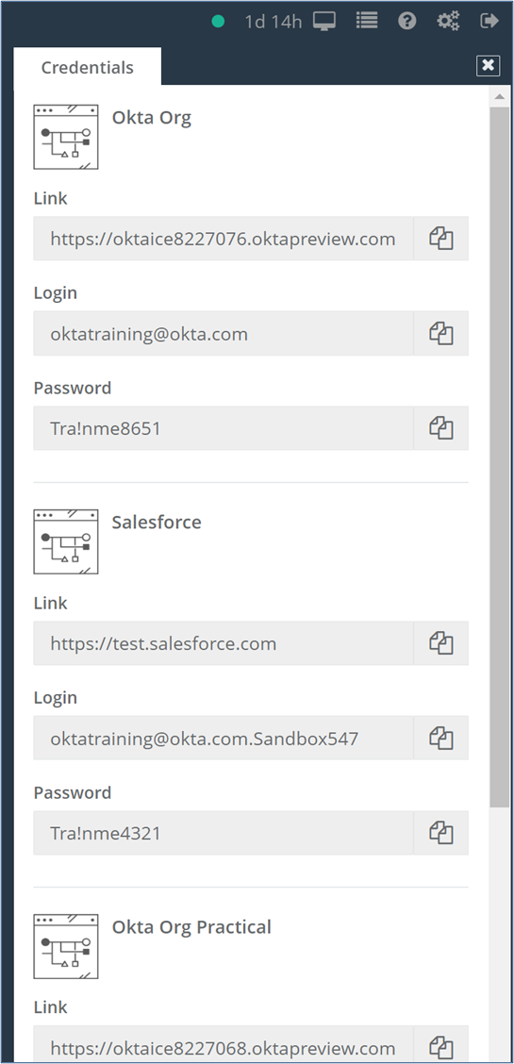
3. In your Chrome browser, place the cursor in the URL field, and then click the Paste to VM button next to the Okta Org link.  
   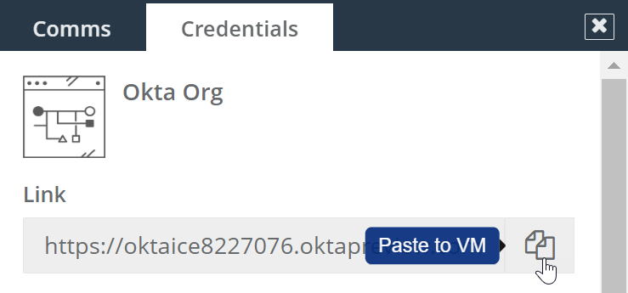
4. You should see the URL is pasted in the field. Press **Enter**.  
   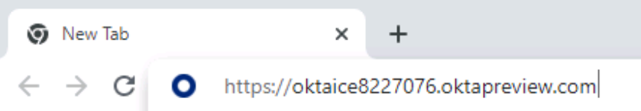  
   On the **Okta Sign In** page, copy and paste the username and password from the Credentials tab.  
   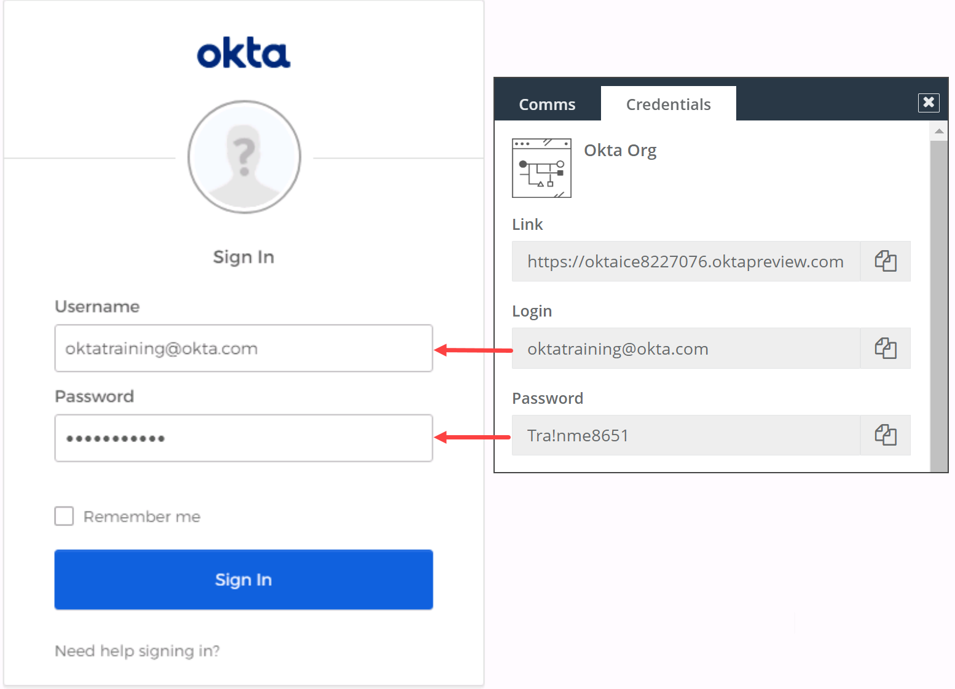

**Note:** oktatraining is a pre-seeded user in your org with Super Admin permission.

1. Click **Sign In**.  
   You will land on the dashboard page of the Okta Administrator console.

## Lab 2-1: Create Okta-sourced Users

|  |  |
| --- | --- |
| **Objective** | Create users in Okta. |
| **Scenario** | Okta Ice will be using the Okta Identity Service and hired you as consultant to lead their implementation. In your first task as consultant, you will create three accounts via the Admin UI. |
| **Duration** | 10-15 minutes |

### Before You Start

Make sure you can log into the Okta Org assigned to you.

### Create the Okta Admin Account

In this section, you’ll create and activate three accounts using the Okta Admin console.

This dashboard page of Okta Admin console provides a summary of app usage and org activity and notifies you of any problems or outstanding work to be completed. You can find more information about dashboard on this website: <https://help.okta.com/en/prod/Content/Topics/Dashboard/Dashboard.htm>

1. In Okta Admin console’s sidebar main menu, navigate to **Directory** > **People**.
2. To create an account, click **Add Person**.
3. Complete the following fields with values as shown in the table below:

|  |  |
| --- | --- |
| **Field** | **Value** |
| User type | **User** |
| First name | **Okta** |
| Last name | **Admin** |
| Username | **okta.admin@oktaice.com** |
| Primary email | **okta.admin@oktaice.com** |
| Secondary email | **your work or personal email** |
| Password | **Set by admin** |
| Enter Password | **Tra!nme4321** |
| User must change password at first login | **Unchecked** |

1. Click **Save and Add Another**.

### Create the AD Admin Account

1. Add a user account with the following values:

|  |  |
| --- | --- |
| **Field** | **Value** |
| First name | **AD** |
| Last name | **Admin** |
| Username | **ad.admin@oktaice.com** |
| Primary email | **ad.admin@oktaice.com** |
| Secondary email | **your work or personal email address** |
| Password | **Set by admin** |
| Enter Password | **Tra!nme4321** |
| User must change password at first login | **Unchecked** |

1. Click **Save and Add Another**.

### Create the Personal Account

1. Add another user account with the following values:

|  |  |
| --- | --- |
| **Field** | **Value** |
| First name | **<Your First Name>** |
| Last name | **<Your Last Name>** |
| Username | **<firstname.lastname@oktaice.com>** |
| Primary email | **<firstname.lastname@oktaice.com>** |
| Secondary email | **your work or personal email address** |
| Password | **Set by user** |
| Send user activation email now | **selected** |

1. Click **Save**.  
   You are returned to the People page.
2. Click **Show all users** to review the state of user accounts listed in the status column.   
   You should see 4 accounts are **Active** and one account is **Pending user action**.

### Activate the Personal Account

1. In your Workspace, open a new browser tab to launch your email client and check the inbox of the email address you entered as a secondary email—either your work or a personal email address.
2. Open the **Welcome to Okta!** message and click the activation link.
3. Enter the password suggested by your instructor. For example, **Tra!nme4321**.
4. Select and answer a password reset question of your preference.
5. Select an image of your preference and click **Create My Account**. You are automatically redirected to the End User dashboard which doesn’t have any applications now.
6. Sign out of your personal account.

## Lab 2-2: Assign Administrative Roles

|  |  |
| --- | --- |
| **Objective** | Grant administrative roles for administrators and service accounts. |
| **Scenario** | Okta Ice just subscribed to Okta, received its Okta org, and hired you as consultant to lead their implementation.  As your first task, you created and imported a few users to your Okta org. These users don’t have any administrative privilege or apps assigned to them. In this task, you grant administrative roles for some of your users. |
| **Duration** | 5-10 minutes |

### Assign Okta Administrative Roles Based on Job Role

1. Log back into Okta Org as **oktatraining**.
2. If necessary, click **Admin**.
3. Navigate to **Security** > **Administrators**.
   1. To grant the Super Administrator role to Okta Admin: Click **Add Administrator** on the lower right.
   2. In the **Admin** search field, type **Okta** and then select **Okta Admin**.
   3. In the **Role** field under Complete the assignment, click the drop-down menu, type **super** and select **Super Administrator**.

**Note**: If you need to assign multiple roles to an administrator account, use **Add assignment**.

* 1. Click **Save Changes**.  
     You will automatically land on the Overview tab page.

**Note:** The Okta Admin account requires the Super Administrator role for performing all administration and configuration tasks in Okta.

1. Repeat the previous steps to grant administrative roles for the remaining users:

|  |  |  |
| --- | --- | --- |
| **User** | **Administrative Role** | **Why?** |
| AD Admin | Super Administrator | For use as service account in AD and Desktop SSO configurations |
| Personal Account | Org Administrator and Application Administrator | For use as your personal user administrator account with the correct amount of permissions |

1. In the Administrators page, click the **Admins** tab to review the role assignments.
2. Sign out of the oktatraining account by using the drop-down menu in the top-right corner of the Admin console.  
   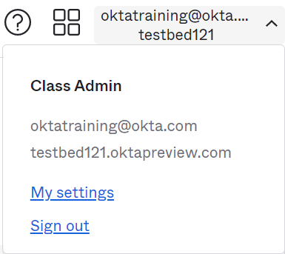

### Conclusion

Now that you have created Okta-sourced users and assigned various administrative roles, you are now ready to learn how to integrate directories and set up JIT provisioning.

## Lab 3-1: Integrate an Active Directory Instance (Part 1 of 2)

|  |  |
| --- | --- |
| **Objective** | Install the Active Directory agent. |
| **Scenario** | For your Okta Ice employees, you use Active Directory as the directory service. For the employees to benefit from Okta, you must configure an Active Directory integration. |
| **Duration** | 10-15 minutes |

### Before You Start

|  |  |
| --- | --- |
| **Lab Requirement** | **Required by** |
| Verify the following accounts are **created and active** with the super admin role in your Okta org:   * ad.admin * okta.admin | Lab 3-1, 3-2  Lab 3-3, 3-5 |

### Install an Okta AD Agent

1. In your Workspace, on the **Okta Sign In** page, sign in with the **ad.admin** credentials.  
   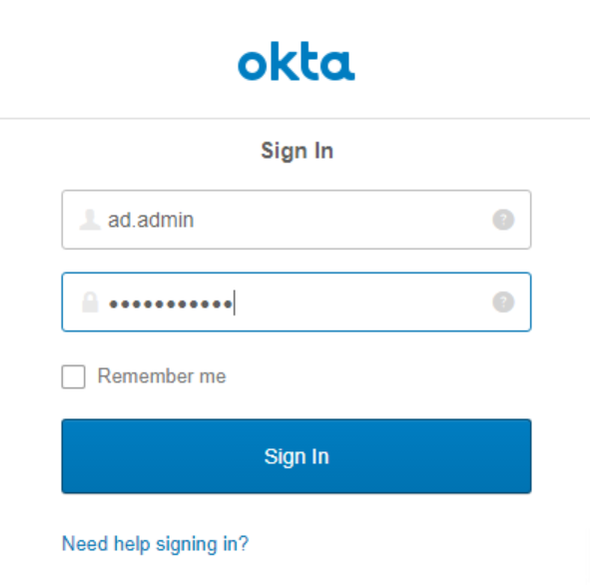
2. Select and answer a password reset question of your preference.
3. Click **Create My Account**. You are automatically landed in the Admin console.
4. Navigate to **Directory** > **Directory Integrations**.
5. Select **Add Directory** > **Add Active Directory**.
6. Review the **Set Up Active Directory** page, scroll to the bottom, and click **Set Up Active Directory**.
7. On the Download Agent tab, click **Download Agent**.  
   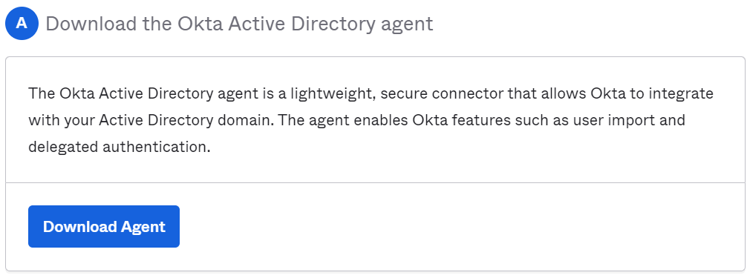
8. Navigate to the Windows Explorer **Downloads** folder, right-click the **OktaADAgentSetup-#####.exe** file and then click **Run as administrator**.  
   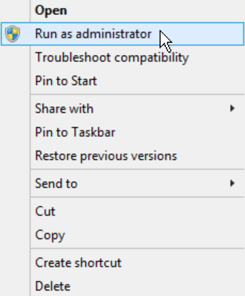
9. If a security warning dialog box appears, click **Run**.
10. Complete the **Okta AD Agent** installation wizard as follows:
    1. In the **Okta AD Agent** dialog box, click **Next**.
    2. Accept the default installation folder and click **Install**.
    3. Accept the domain for the user accounts as oktaice.local and click **Next**.
    4. For this lab, accept the default OktaService account selection and click **Next**.
    5. In the Password and Retype password fields, enter **Tra!nme4321**  
       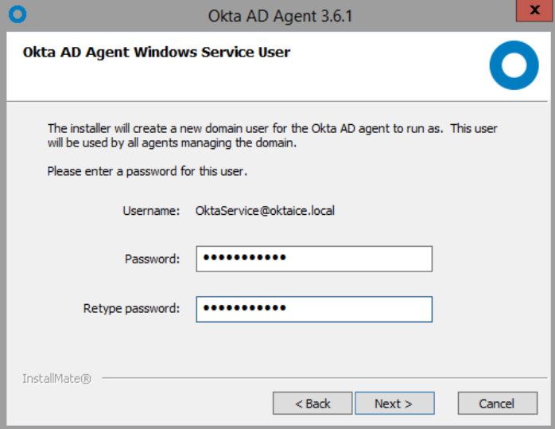
    6. Click **Next**.
    7. Do not configure any AD agent proxies. Click **Next**.
    8. On the **Register Okta AD Agent** page, enter your Okta org URL in the format of https://oktaice####.oktapreview.com/  
       **Tip:** You can copy and paste the value from the **Link** field under **Essentials Org** on the Credentials tab.
    9. Click **Next**.
    10. When prompted, sign into Okta with the **ad.admin** account.
    11. When prompted to grant access to the Okta API, click **Allow Access**.  
          
        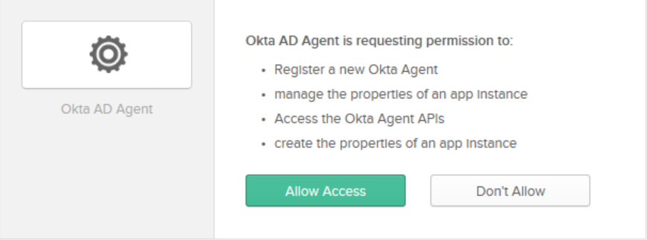
    12. When the installation completes, click **Finish**.
11. Go back to your web browser, you should see a dialog box showing the AD agent is started. Click **Next**.  
    You are returned to the Set up Active Directory page to continue the Active Directory integration configuration.

### Configure the basic settings for AD agent setup

1. On the **Basic Settings** tab, perform the following:
   1. Select the OUs containing the **Users** (top section) and **Groups** (bottom section) containing the resources.
      1. In the Users section, select employees, interns, and partners.
      2. In the **Groups** section, select **employees**, **interns, and partners**.  
         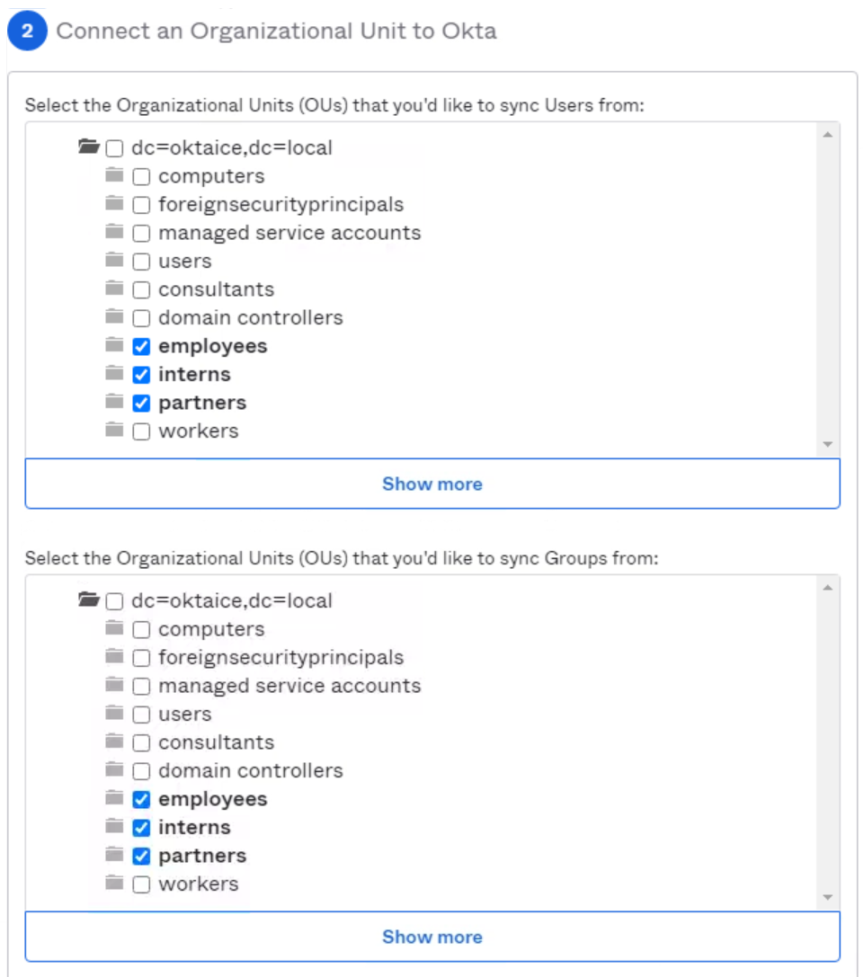  
         **Note**: You need to deselect the root node "dc=" in order to select the 3 OUs specified.
   2. Accept the default selections including User Principal Name (UPN) as the Okta username format.
   3. Click **Next**.
2. In the Import AD Users and Groups dialog box, click **Next**.
3. On the **Build User Profile** tab, perform the following:
   1. In the **Search** field, type and then select the following attribute: **favoriteIceCreamFlavor**

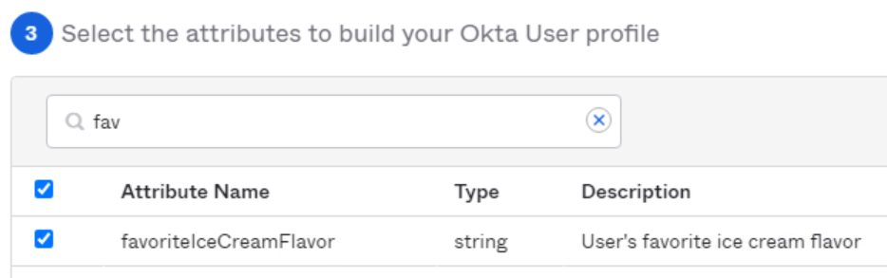

* 1. Click **Next**.

1. On the **Done** tab, review the information and click **Done**. The page refreshes to the **Provisioning** tab for the Active Directory instance.

**Notes:** If you miss Step 3 or want to add more attributes in the future, here is what you can do:

1. In the Admin Console, go to **Directory** > **Profile Editor**.
2. Locate the AD directory **oktaice.local User** and then clickthe link.
3. In the Profile Editor page, click **Add Attribute**.
4. In the pop-up Pick Schema Attribute window, search and add the attribute favoriteIceCreamFlavor.
5. Click **Save**.

## Lab 3-2: Integrate an Active Directory Instance (Part 2 of 2)

|  |  |
| --- | --- |
| **Objective** | Import users using JIT, then with a manual/scheduled import. |
| **Scenario** | For your Okta Ice employees, you use Active Directory as the directory service. For the employees to benefit from Okta, you must configure an Active Directory integration. |
| **Duration** | 10-15 minutes |

### Setup up JIT Provisioning

1. Navigate to Directory > Directory Integrations and select **Active Directory** (oktaice.local)

You will automatically land on the **People** tab. Notice that no user records appear. This is because the import has not yet occurred.

1. Click the **Provisioning** tab.
2. Under Settings, click **To Okta**.
3. In the General section, Click **Edit**.
4. To enable JIT Provisioning, select:
   * Create and update users on login
   * Skip users during import

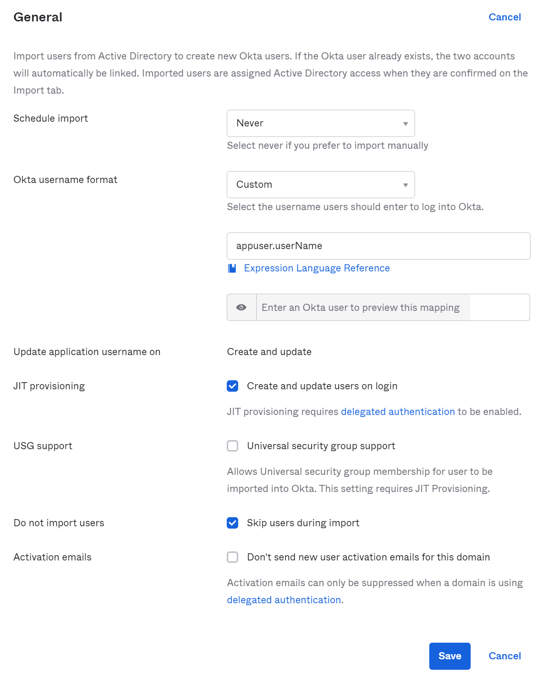  
**Note:** You should not import users from AD in advance when using JIT for provisioning users to Okta.

1. Click **Save**.
2. Log out of Okta as AD Administrator.
3. Log in with **jennifer.jones** to test the JIT functionality:
   * **Username:** jennifer.jones
   * **Password:** Tra!nme4321
4. Select a security image, select **Create My Account**. Notice that no password recovery question is prompted. This is because you have not made configurations that allow AD users to perform self-service password reset or account unlock in Okta.
5. Click on **Jennifer** and select **Settings.**
6. Clickon **Edit** next to Personal Information. Notice that you cannot change the attributes pulled from Active Directory.  
   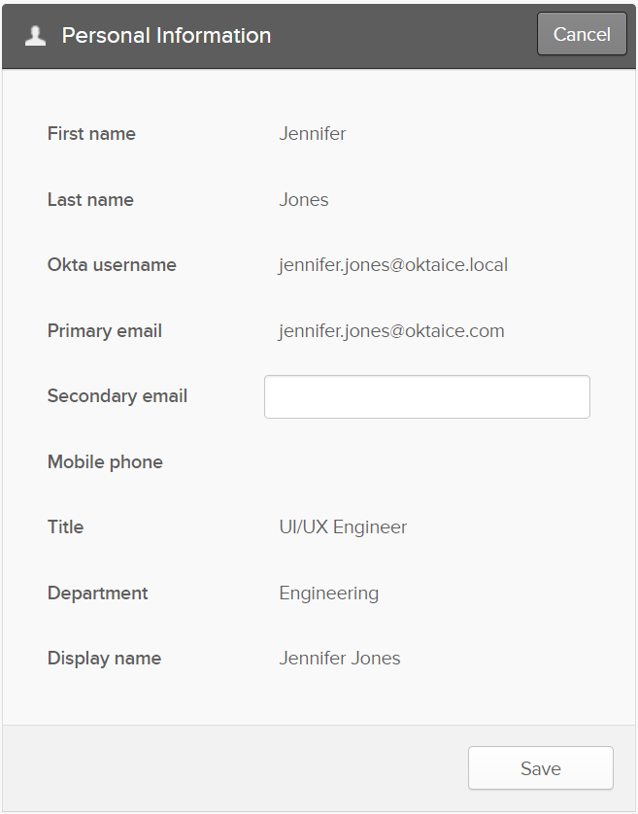
7. Sign out of the account**.**

### Disable JIT Provisioning and Import Users

1. On the **Okta Sign In** page, sign in with the **okta.admin** credentials.
2. When prompted, select an image of your preference Select and answer a password reset question of your preference.
3. Navigate to **Directory** > **Directory Integrations** and select **Active Directory** (oktaice.local)
4. Click the **People** tab. Notice that only **Jennifer.Jones** appears. This is because Jennifer was imported with JIT and no others have been imported yet.  
   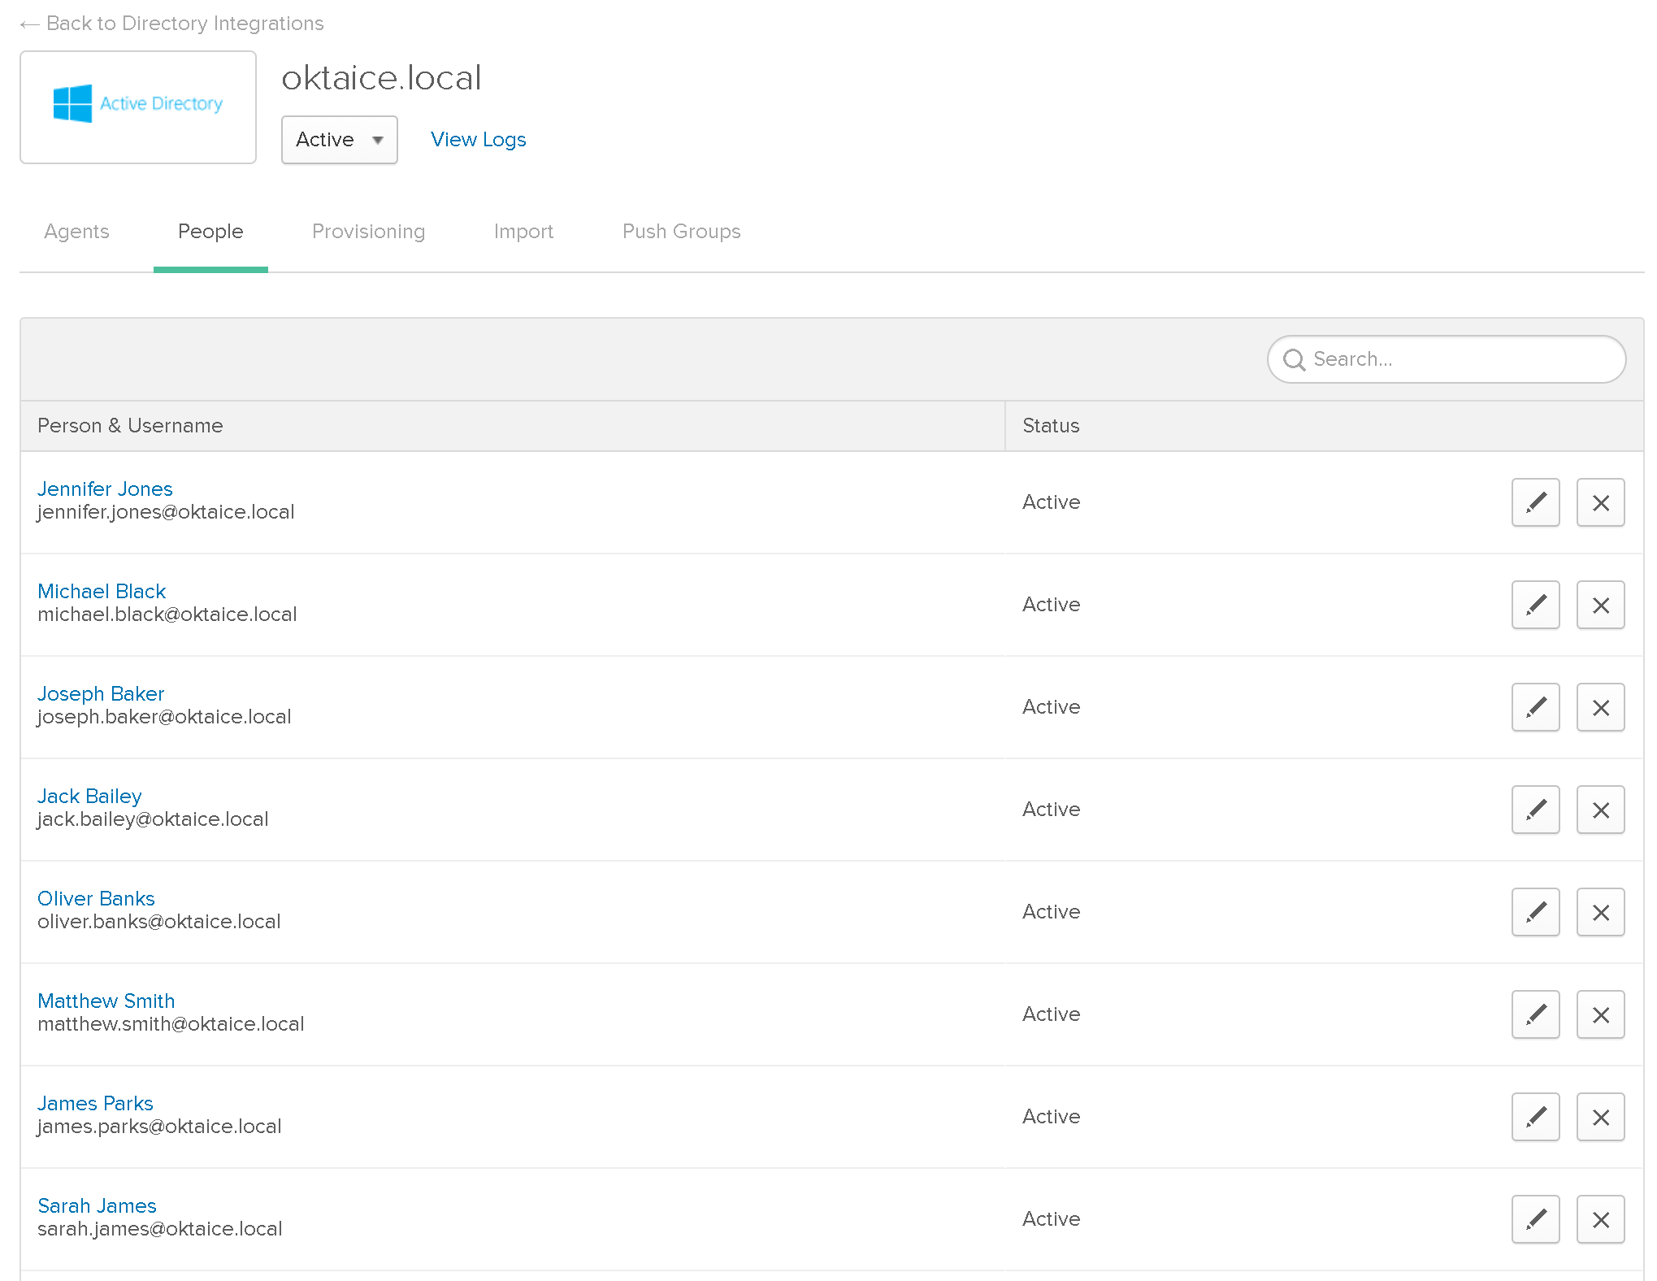
5. Click the **Provisioning** tab.
6. Under Settings, click **To Okta**.
7. In the General section, Click **Edit**.
8. To turn off JIT Provisioning, uncheck:
   * Create and update users on login
   * Skip users during import.
9. Next to Schedule import, select **Every 6 hours** for the import interval.
10. Click **Save**.
11. Click the **Import** tab.
12. Click **Import Now**.
13. In the **Import from Active Directory** dialog box, select **Full import** and then click **Import**.   
    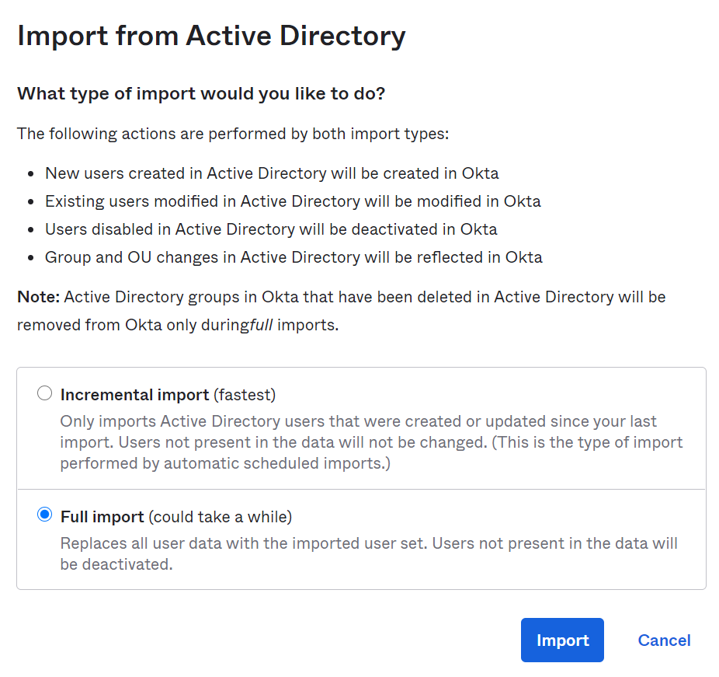  
    A dialog box appears indicating how many users and groups were scanned.
14. Click **OK**.
15. In the **Show** list, select **50**.
16. In the top-right corner of the table and to the right of the **Okta User Assignment** label, click the **Select All** box.  
    
17. Click **Confirm Assignments 31**.
18. In the Confirm Imported User Assignments dialog box, select **Auto-activate users after confirmation** and then click **Confirm**.

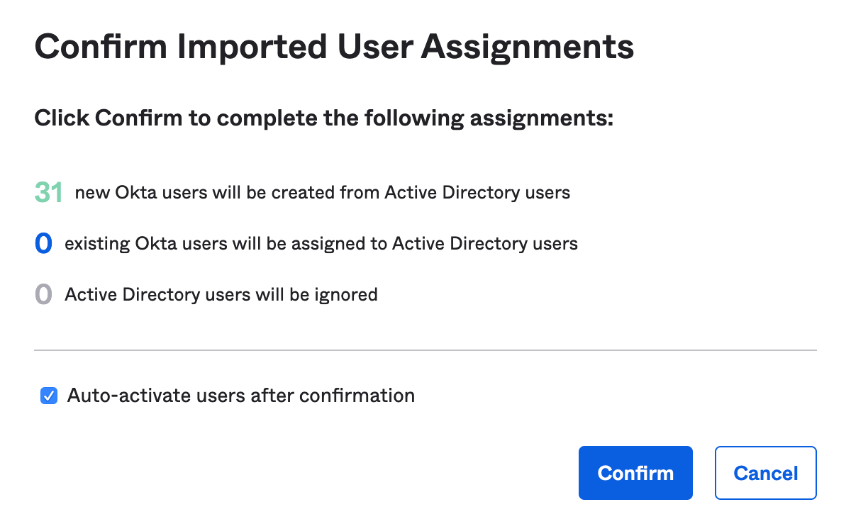

1. Click the **People** tab. All Active Directory users should appear.
2. Stay logged into the Okta Admin console.

## Lab 3-3: Delegated Authentication - Manage AD Password from within Okta

|  |  |
| --- | --- |
| **Objective** | Add Rule to Active Directory Password Policy |
| **Scenario** | Okta Ice wants their Active Directory Sourced users to be able to reset their AD Password inside of Okta and have it update Active Directory to eliminate AD Administrative tasks. |
| **Duration** | 5-10 minutes |

### Create an Active Directory Password Policy

1. Navigate to **Security** > **Delegated Authentication**.
2. On the **Active Directory** tab, click the **password policy** link.  
   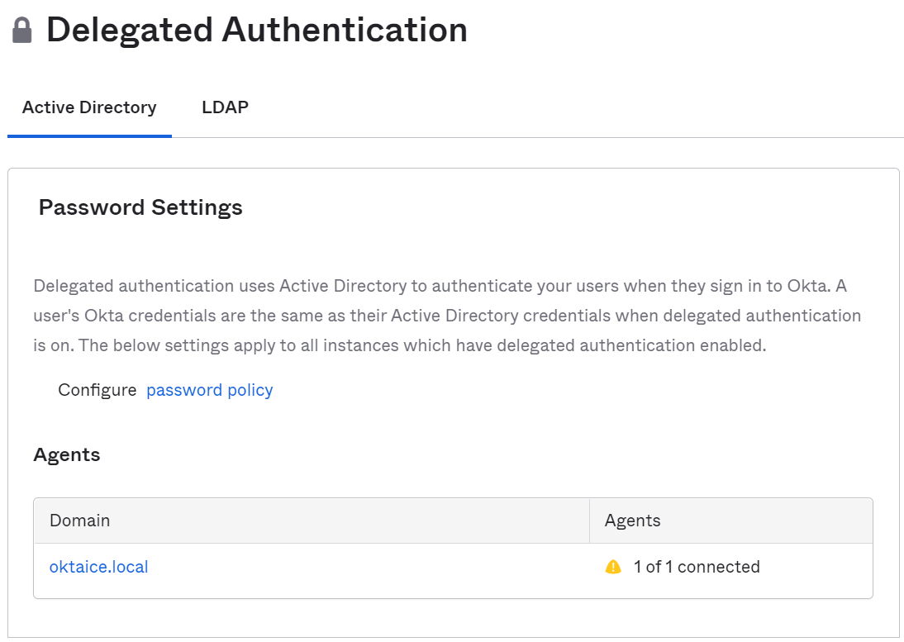  
   You are redirected to the Authentication page on the **Password** policy tab.   
   **Note:** You can also navigate to this page by selecting **Security > Authentication**.
3. With the **Active Directory** **Policy** selected, scroll down to the bottom of the page, click **Add Rule** in the rule table.
4. In the **Add Rule** dialog box, perform the following:
   1. In the **Rule Name** field, type the following: **Account Updating**
   2. Leave the **Exclude Users** field blank.
   3. In the **If user’s IP is** list, accept the default value **Anywhere**.
   4. Next to **the user can**, select the following options:
   * change password
   * perform self-service password reset
   * perform self-service account unlock
   1. Click **Create Rule**.  
      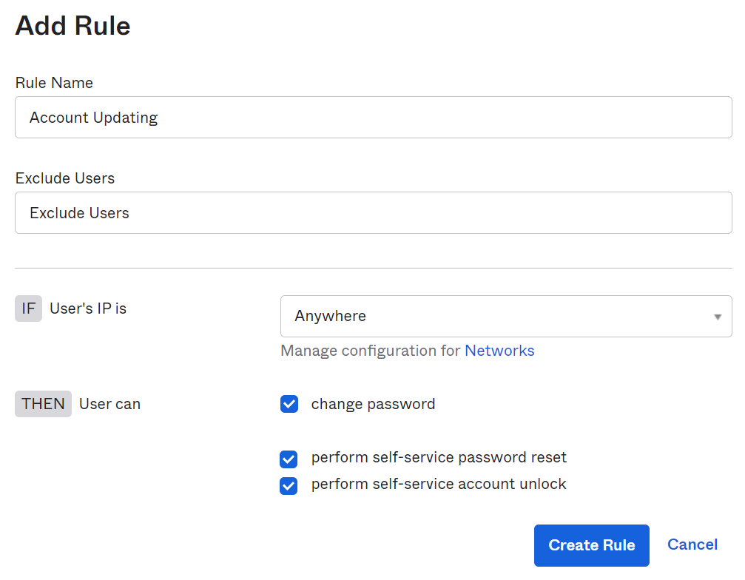
5. Log out and log in as **jennifer.jones** to verify the AD password self-service functionality, more specifically password change is enabled.
6. Complete the information as follows:
   1. Provide a secondary email.
   2. Select a forgot password question and provide an answer.
7. Click **Create My Account**.

**Note:** Unlike the behaviors when signing-in in Lab 3-2, Jennifer is now prompted for password recovery question and providing a secondary email because the policy rule you added that allows users to reset their passwords and unlock accounts.

1. Click on **Jennifer** and select **Settings** and you should see the section where you can change password.
2. Sign out of the Jennifer account.

### Promote the Active Directory Service Account

The steps performed in this lab is to support Active Directory account update and password reset.

1. In your Workspace, **on** Windows Taskbar, click the **Search** (magnifying glass) icon.
2. In the search field, type and select the following:  
   **Okta AD Agent Manager**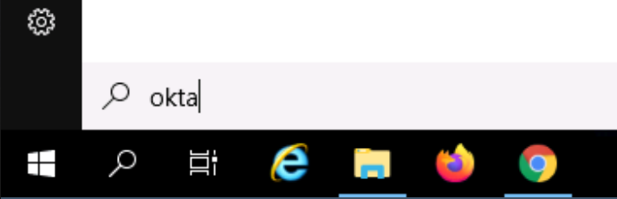
3. In the Okta AD Agent Manager Utility window, expand **Service Account**.
4. Click **Add to Domain Admins group**.  
   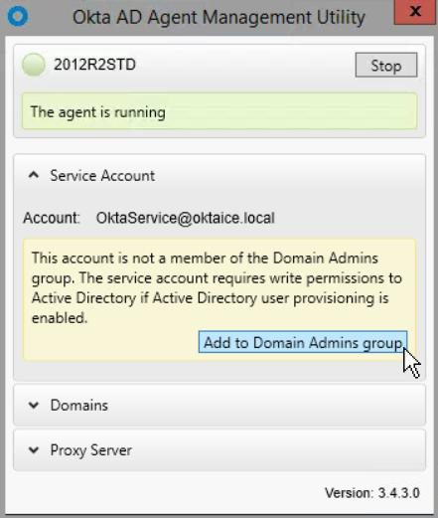  
   The agent will shut down and restart.

**Note:** Adding the AD Service Account to the Domain Admins group will elevate the Service Account’s permission so it can reset user passwords in AD. This is only for use in test environments.

1. Close the Okta AD Agent Manager Utility window.

## Lab 3-4: Fine Tune the Active Directory Agent

|  |  |
| --- | --- |
| **Objective** | * Explore the OktaAgentService.exe.config file. * Understand the config file properties. * Modify the Agent settings. |
| **Scenario** | Okta Ice would like to fine tune the Active Directory Agent to use more threads to handle authentication since they are expecting a larger load of employees to join the company. To accomplish this, you explore and update the Okta Agent Service Config file. |
| **Duration** | 5-10 minutes |

### Backup and Open the Okta Agent Service Config file

1. In your Workspace, launch File Explorer and navigate to:  
   C:\Program Files (x86)\Okta\Okta AD Agent
2. Copy the **OktaAgentService.exe.config** and paste it into the same folder.
3. Rename the file to **OktaAgentService.exe.bak.config**. If asked to change the file name extension, select **YES**.  
   This step saves a copy of the original file to revert to if needed.
4. Open and edit the OktaAgentService.exe.config file in Notepad:
5. Right-click **OktaAgentService.exe.config**, select **Open with...** and then select **More apps**.
6. Scroll down and select **Notepad**.
7. Click **OK**.   
   Notepad will launch with the config file opened.
8. Review the config file properties:

**Note:** The config file contains the following properties:

* **BaseOktaURI**: your org uri.
* **AgentToken**: Encrypted API token that the agent uses to call Okta.
* **AgentId**: Unique identifier for the agent, generated during installation.
* **AgentName**: Human readable ID for the agent. By default, this is the hostname of the domain controller on which the agent is installed. Changes to the value are reflected in the Okta AD Agent Manager but not in Okta.
* **AppId:** Unique identifier for the directory to which this agent belongs. The AppId forms part of the URL when you are on the directory integrations page for this instance.
* **ProxyURL**, **ProxyUsername**, and **ProxyPassword (encrypted)**: - The proxy used by this agent, if any. If there is no value, a proxy won’t be used.
* **PollingThreads:** The number of concurrent polling requests (between 1 and 10) running between the agent and Okta. A number outside this range sets the number of threads at the minimum or maximum (whichever boundary is exceeded). The default value is 2.
* **VerboseLogging**: If true, the log contains more information (mostly in the user provisioning flow).
* **ConnectionLimit**: The value for system.net.servicepointmanager.defaultconnectionlimit. The default .NET limit of two concurrent connections is maintained if Okta fails to parse the value of this setting.
* **MaxRetryLimitSleep**: Related to circumstances when an agent is unable to reach Okta. The intervals during which disconnected agents are not polling Okta become progressively longer. When the agent is reconnected, polling resumes at the normal frequency. This setting specifies the duration of non-polling ("sleep") intervals. By default, this setting is set to the maximum setting of 1 hour in milliseconds (3600000).
* **SslPinningEnabled**: When SSL pinning is enabled, the AD agent confirms that the SSL certificate presented by the Okta org matches one of the keys hard-coded in the agent.

**Tip:** For the latest properties, check the official documentation: <https://help.okta.com/en/prod/Content/Topics/Directory/ad-agent-appsettings.htm>

1. Change the Polling Threads value to **4**.  
   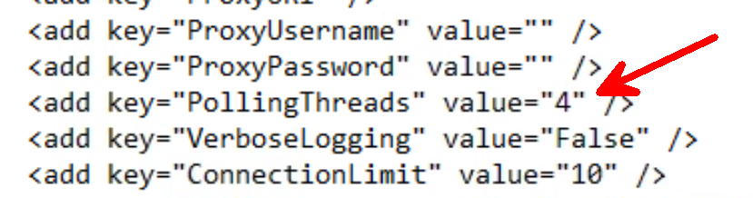
2. Click **File** > **Save**.
3. Click **File** > **Exit.**

### Restart the Okta AD Agent

1. In File Explorer, double click on **OktaAgentManager.exe** to open the Okta AD Agent Management Utility.
2. Click **Stop**. Wait for the service to stop, and then click **Start**.   
   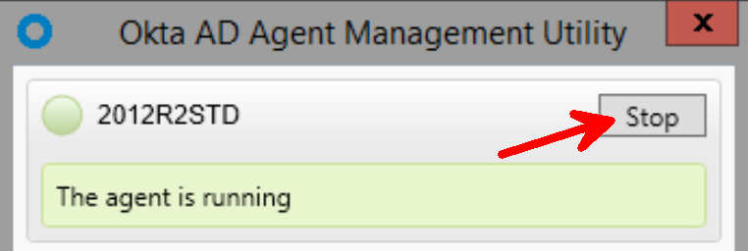
3. Once the agent shows that it is running, close out of the utility.

### Confirm Number of Threads being Utilized

1. Double click on the **logs** folder.
2. Double click on the **Agent.log**, which should automatically open in Notepad.
3. Scroll to almost the bottom of the log file, where the configuration file is loaded, and verify there are four threads being utilized by the agent.

**Note:** If you cannot find this reference, scroll to the very bottom of the file and click on the last line of text. Search the log file upward for **PollingThreads** (**Edit > Find**, then change direction to Up).

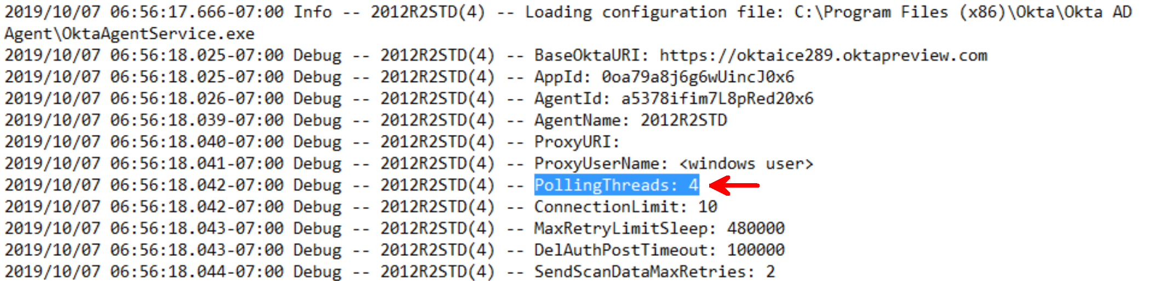

1. Select **File** > **Exit**.

## Lab 3-5: Configure Agentless DSSO

|  |  |
| --- | --- |
| **Objective** | Integrate Desktop SSO with Active Directory. |
| **Scenario** | For a complete SSO experience, enable and configure Desktop SSO. |
| **Duration** | 15-20 minutes |

### Enable AES Encryption for the Service Account

In this first task, you will enable Kerberos AES 128 bit encryption and/or Kerberos AES 256 bit encryption for the service account so that KDC can generate Kerberos tickets with AES encryption types.

1. In your Workspace, launch the **Active Directory Users and Computers** application from Windows Taskbar.  
   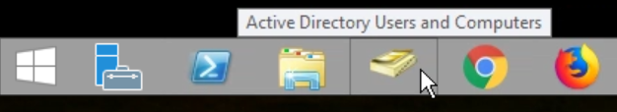
2. In the Active Directory Users and Computers app, expand the domain controller **oktaice.local** and select **Users** in the left navigation pane.  
   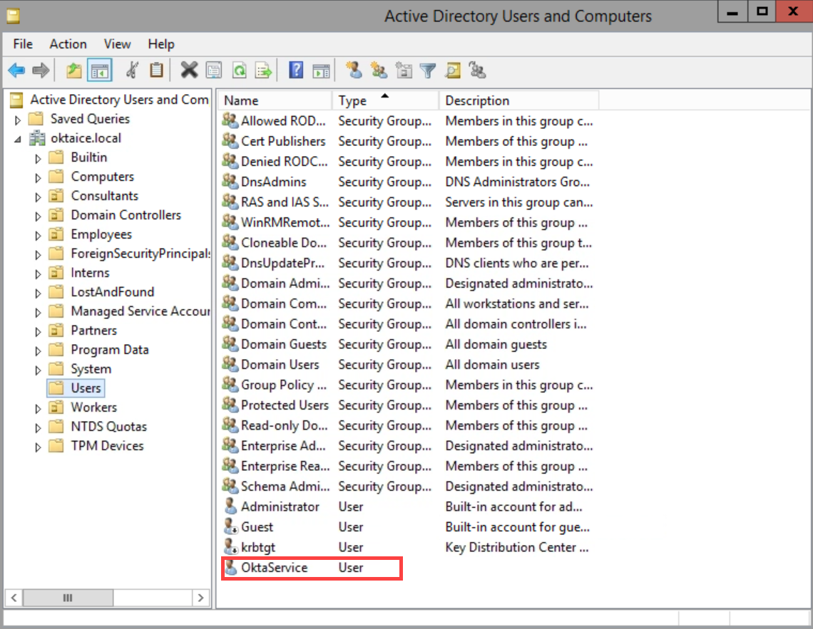  
   You should see **OktaService**, the service account displayed in the right pane.
3. Right-click **OktaService** and select **Properties** from the pop-up menu.
4. In the **OktaService Properties** window, select the **Account** tab.
5. In the **Account options** field, scroll to locate and enable the following two options:
   * This account supports Kerberos AES 128 bit encryption.
   * This account supports Kerberos AES 256 bit encryption.  
     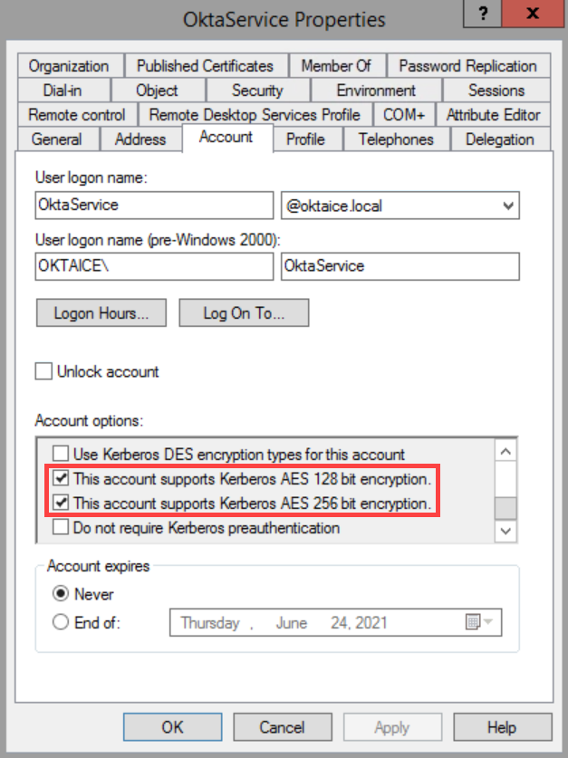
6. Click **OK**.
7. Close the Active Directory Users and Computers application.

### Register SPN for the Service Account

1. In Windows Taskbar, open the **Command Prompt** application.
2. Enter the following command in the window:  
   **setspn -S HTTP/oktaice*####*.kerberos.oktapreview.com OktaService**Replace #### with your Okta Org number.

**Notes:**

* SPNs are not case sensitive when used by Microsoft Windows-based computers.
* OktaService is the service account that was created in Active Directory during the Active Directory Agent installation and resides in the Users OU. A different AD service account could be created and bound to DSSO with a SPN. To learn more about SPNs, refer to <https://docs.microsoft.com/en-us/previous-versions/windows/it-pro/windows-server-2012-R2-and-2012/cc731241(v=ws.11)>.

1. Press **Enter**.
2. Verify a successful registration.  
   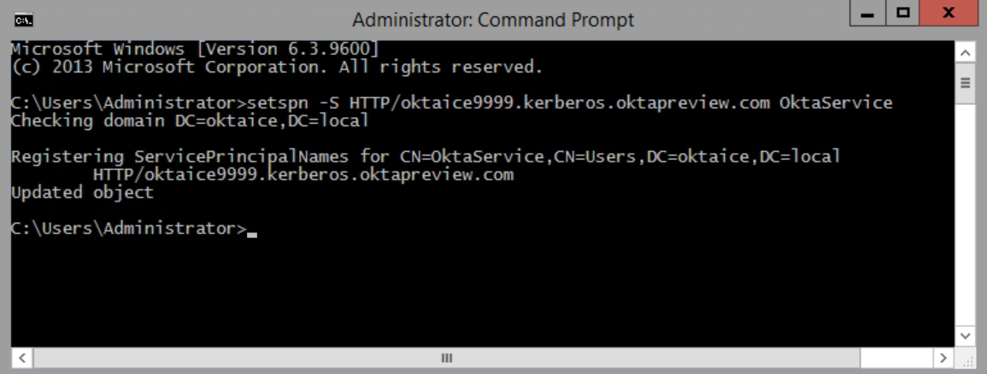
3. Close the Command Prompt window.

### Enable Agentless Desktop SSO

1. Open your Okta org sign-in page in a browser tab.
2. Log in as **okta.admin**.
3. Navigate to **Security** > **Delegated Authentication**.
4. Scroll to Agentless Desktop SSO and Silent Activation, and click **Edit**.
5. Under Desktop SSO mode, select **On**.
6. Under ACTIVE DIRECTORY INSTANCES, click **Edit** (the pencil icon)next to your Active Directory domain.
7. In the dialog box, edit the following fields:
   * Desktop SSO: **Enabled**
   * Service account username: **OktaService**
   * Service account password: **Tra!nme4321**

**Note:** Okta service account is case-sensitive and must be entered as OktaService with the O and the S capitalized. Although oktaservice will be accepted for validation, this will cause the lab to fail when testing at the end.

1. Click **Save** to close the dialog box.  
   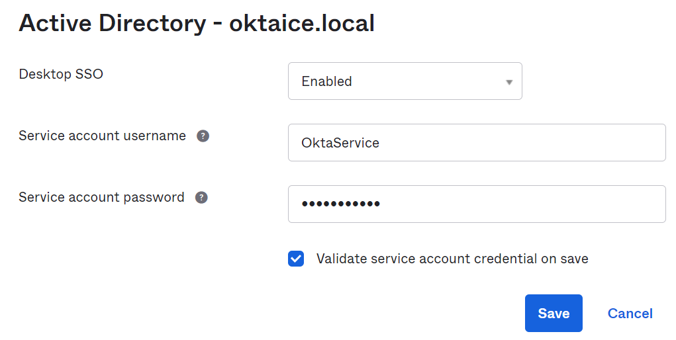

You should see your Active Directory instance is enabled for agentless DSSO.

1. Scroll to the bottom of the Delegated Authentication page, click **Save**.

### Define the Network Zone

1. Navigate to **Security** > **Networks**.
2. Click **Edit** (the pen icon)for **LegacyIpZone**
3. In the Edit IP Zone window, use your current VM IP address for **Gateway IPs** by clicking the IP shown next to **Add your current IP address**.   
   **Note**: This VM Public IP will be used for testing Agentless DSSO.
4. Click **Save**.

### Configure the Routing Rule

1. Navigate to **Security** > **Identity Providers**.
2. Select the **Routing Rules** tab.  
   Note there is a Routing Rule already defined for Agentless DSSO.
3. Click on the Edit button of the Default Route to AgentlessDSSO rule.
4. In the Edit Rule window, configure the following settings:
   1. Change **User’s IP is** to **In Zone**, then in the Zones area search and select **LegacyIpZone**.
   2. Accept the default selections for the rest settings.
   3. Click **Update Rule**.
5. You are returned to the Routing Rules tab page, change the rule’s state from Inactive to **Activate**.  
   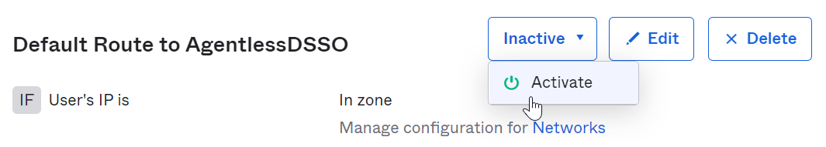
6. When a confirmation dialog box pops up, click **Activate**.

### Configure Chrome for Agentless DSSO

1. Open the Windows **Start** menu and select the **Remote Desktop Connection** tile  
   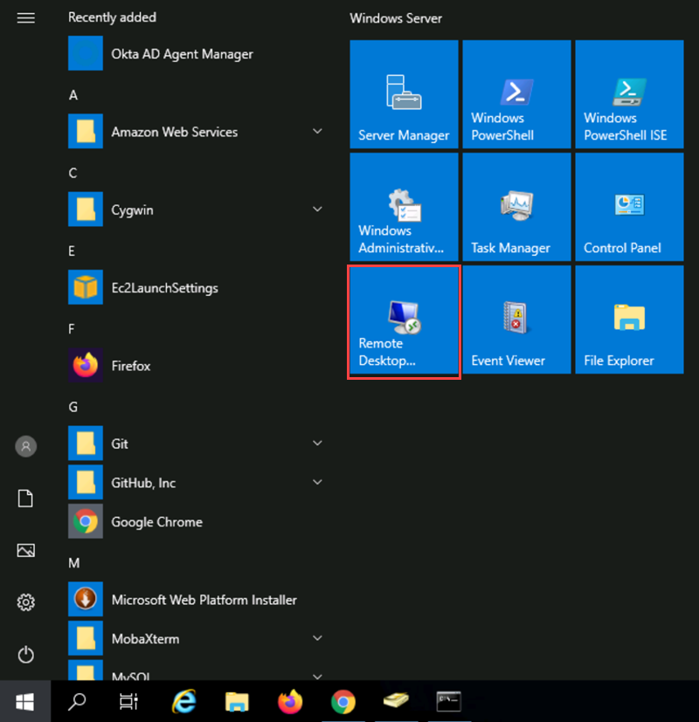
2. In the dialog box, click **Show Options**.
3. In Logon Settings, edit the following fields:
   * + Computer: **localhost**
     + User name: **jennifer.jones@oktaice.com**
4. Click **Connect**.
5. When prompted for password, enter **Tra!nme4321**
6. Click **OK**.
7. Click **Yes** to ignore the security warning.  
   You will log in as Jennifer Jones through remote desktop services.
8. Open the Windows **Start** menu and select the **Control Panel** tile.
9. Select **Network and Internet** > **Internet Options**. The Internet Properties window appears.
10. Select **Security** > **Local Intranet** > **Sites**. A Local intranet window appears.  
    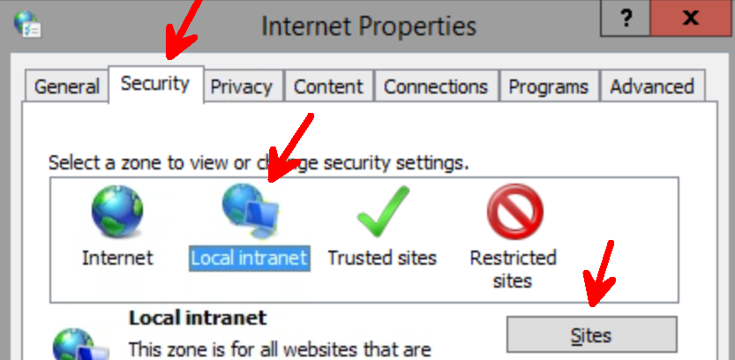
11. Select **Advanced**. A second Local intranet window appears.
12. Enter the following URL as a trusted zone:   
    oktaice***####***.kerberos.oktapreview.com   
    **Note:** Change **####** to match your Okta Org number.
13. Click **Add**.  
    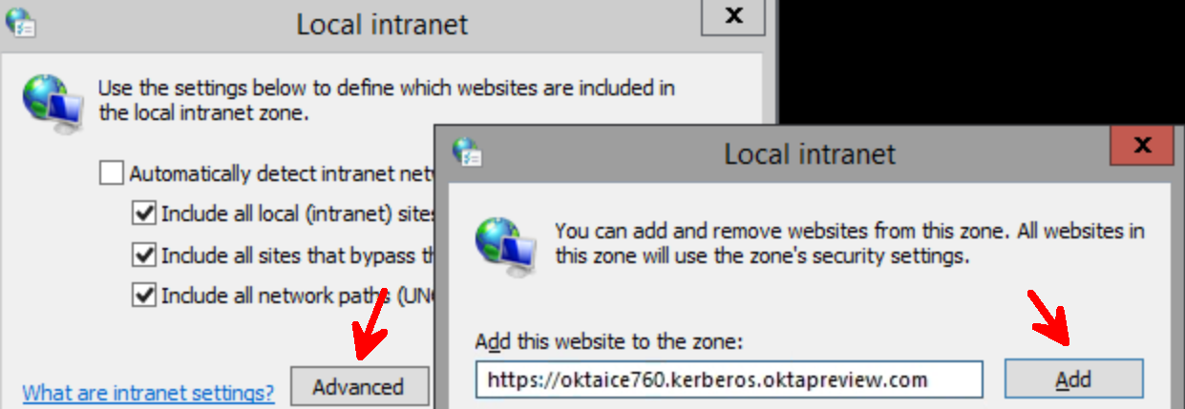
14. Click **Close** to close the second Local intranet window.
15. Click **OK** to close the Local intranet window.
16. Click **OK** to close the Internet Properties window.  
    **Note:** You could use Group Policy (GPO) to roll this out to all client machines that will use Agentless DSSO.

### Test Agentless DSSO

1. Open the Chrome browser and enter your Okta sign-in URL. Verify access is granted without entering any credentials.  
   With agentless DSSO configured, users can automatically access applications after logging into their on-network device.
2. Click the **Close** button on the connection bar on the top of your Workspace**.**   
   
3. When prompted, click **OK** to sign out of the Jennifer Jones’ account.

### Conclusion

Now that you have integrated Active Directory, imported and activated your users, and set up agentless Desktop SSO, you are now ready to create and manage groups.

## Lab 4-1: Manage Users Using Groups

|  |  |
| --- | --- |
| **Objective** | Create Okta groups for better management of application assignment for selected users. |
| **Scenario** | The Sales and Marketing staff require access to the same applications. We need to create Sales and Marketing groups and add the appropriate users to the groups. |
| **Duration** | 10-15 minutes |

**Note: This lab should be completed in the browser on your local computer.**

### Before You Start

Make sure:

* You have completed AD integration and the AD agent is up and running.
* You have created and activated the personal account.
* The okta.admin account is created with the super admin role in your Okta org.

### Create a Sales Group with Okta-sourced Users

1. In your Workspace, return to the browser tab where you logged into your Okta org as okta.admin.
2. Navigate to **Directory** > **Groups**.
3. Click **Add Group**.
4. In the Add Group dialog box, enter the following information:

* Name: **Sales**
* Group Description: **All sales personnel**

1. Click **Save**.
2. On the **Groups** page, enter **sales** in the Search field.
3. In the result list, click the newly created Okta **Sales** group.  
   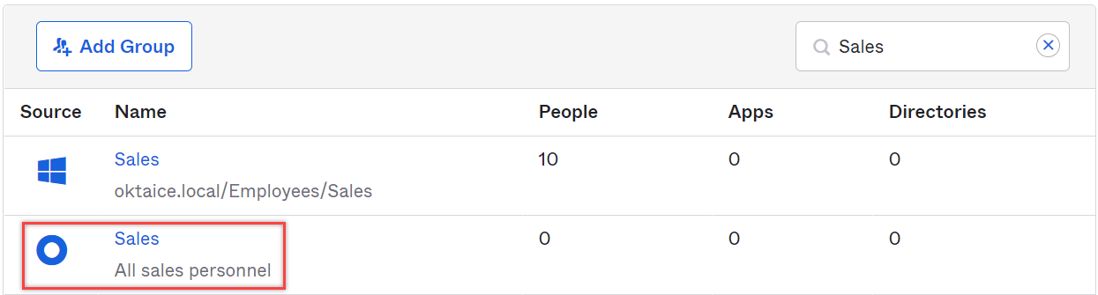
4. With the People tab selected, click **Assign People**.
5. In the search field, enter **okta** and clickthe **search** button.
6. In the search results, add **Okta Admin** to the group.   
   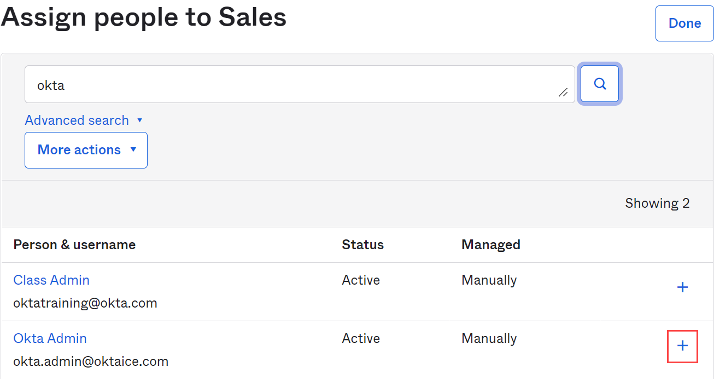
7. Click **Done**.
8. Back on the Sales group page, click **Show all groups**.   
   You should see the user **Okta Admin** appears on the People tab.
9. In the top-left corner, click **Back to Groups**.

### Create a Marketing Group with Okta-sourced Users

1. Click **Add Group**.
2. In the Add Group dialog box, enter the following information:

* Name: **Marketing**
* Group Description: **All marketing accounts**

1. Click **Save**.
2. On the **Groups** page, enter **Marketing** in the Search field.
3. In the result list, select the Okta **Marketing** group.
4. Click Assign People.
   1. In the search field, enter **okta** and click the search button.
   2. In the search results, add **Okta Admin** to the group.
   3. Similarly, add your **personal account** to the group.
   4. Click **Done.**
   5. Back on the Marketing group page, click **Show all groups**.   
      You should see the user Okta Admin and your personal account appear on the People tab.
5. In the top-left corner, click **Back to Groups**.

### Add AD-sourced users to Okta groups using group rules

1. On the **Groups** page, click the **Rules** tab.
2. Click **Add Rule**.  
   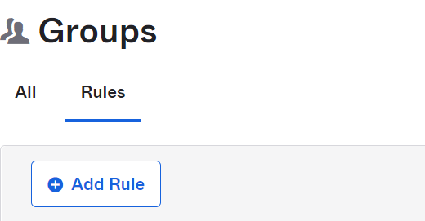
3. In the **Name** field, type **Sales Members.**
4. In the **Expression Builder** section, perform the following:
   1. With **User attribute** selected, type and select **department | string** in the second dropdown field; with **Equals** selected, enter **Sales** in the last field.

**Note:** The string value is case-sensitive.

* 1. Next to **Assign to**, click the drop-down.
  2. In the field type **Sales** and then select the Okta **Sales** group.  
     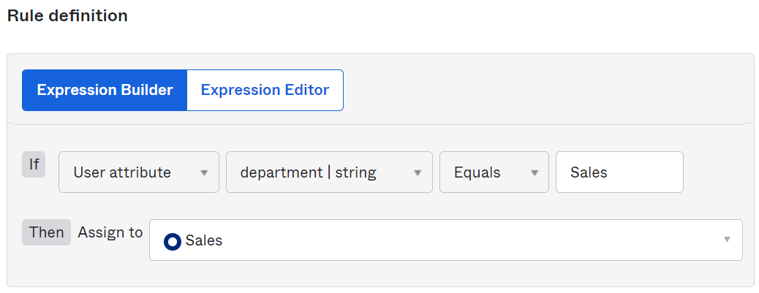
  3. Click **Add Rule**.

1. On the Groups page, to active the rule, click **Inactive** and then select **Activate**.   
   **Note:** If you need to modify a group rule, you must first deactivate the rule.
2. Create another rule for the Okta **Marketing** group.
3. Name the group rule **Marketing Members**.
4. In the **Expression Builder** section, perform the following:
   1. Click the **User attribute** drop-down and select **Group membership**.
   2. In the Enter a group field, type **Marketing** and select the Active Directory **Marketing** group.
   3. Next to **Assign to**, click the drop-down.
   4. In the field type **Marketing** and then select the Okta **Marketing** group.  
      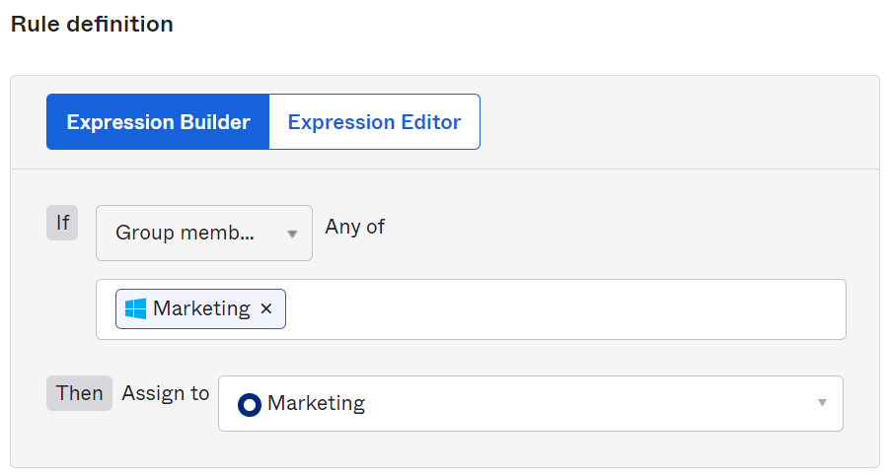
   5. Click **Add Rule**.
5. In the Groups page, activate the **Marketing Members** rule.
6. To verify the group rules are applied, do the following:
   1. Select the **All** tab and click **Show all groups**.
   2. Locate the Okta **Marketing** and **Sales** groups.  
      You should see the number of people in the Marketing group and the Sales group.

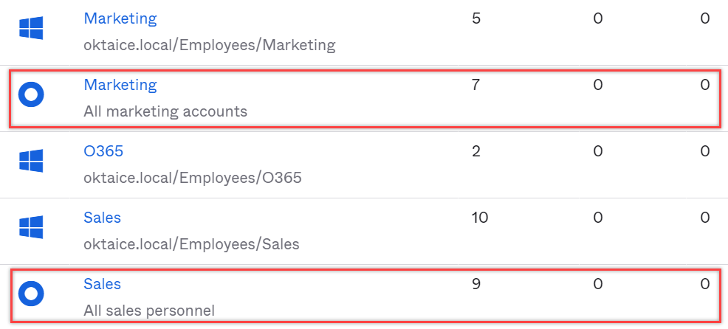

### Conclusion

Now that you have created Okta groups and imported Active Directory groups and have people assigned to both, you are now ready to configure applications.

## Lab 5-1: Add Okta Ice: Gourmet Ice Cream with SWA

|  |  |
| --- | --- |
| **Objective** | Configure Okta Ice: Gourmet Ice Cream using SWA. |
| **Scenario** | The Okta Ice management team needs access to the Okta Ice secret ice cream recipes. They will do this by getting an application assigned to them using a shared username and password. |
| **Duration** | 5-10 minutes |

### Before You Start

|  |  |
| --- | --- |
| **Lab Requirement** | **Required by** |
| You have completed Active Directory integration and the AD and the AD agent are running. | Lab 5-1 |
| The okta.admin account is created with the super admin role in your Okta org. | All labs |
| You have created the Okta Sales group and the Active Directory Sales group is present. | Lab 5-4 |

### Configure Okta Ice: Gourmet Ice Cream using SWA

1. In Okta Admin console, navigate to **Applications** > **Applications**.
2. Click **Browse App Catalog**.  
   The Browse App Integration Catalog page displays.
3. In the Search field, type **Okta Ice**.
4. Select the **Okta Ice: Gourmet Ice Cream** entry from the search result.
5. In the Okta Ice: Gourmet Ice Cream application page, you should see SWA is the only supported sign-on method. Click **Add Integration**.
6. To add the application, on the **General Settings** tab, perform the following steps:
   1. In the Application label field, change the label from Okta Ice: Gourmet Ice Cream to **Okta Ice: Gourmet Ice Cream – Secret Recipes**.
   2. Accept the default choices for Application Visibility and Browser plugin auto-submit.
   3. Click **Next**.
7. On the Sign-On Options tab, in the Sign on methods section, select the **Users share a single username and password set by administrator** option.
   1. In the Shared Username field, type the following: **oktatraining@okta.com**
   2. In the Shared Password field, enter **Tra!nme4321**
   3. Accept the default values as-is for the rest of the settings.  
      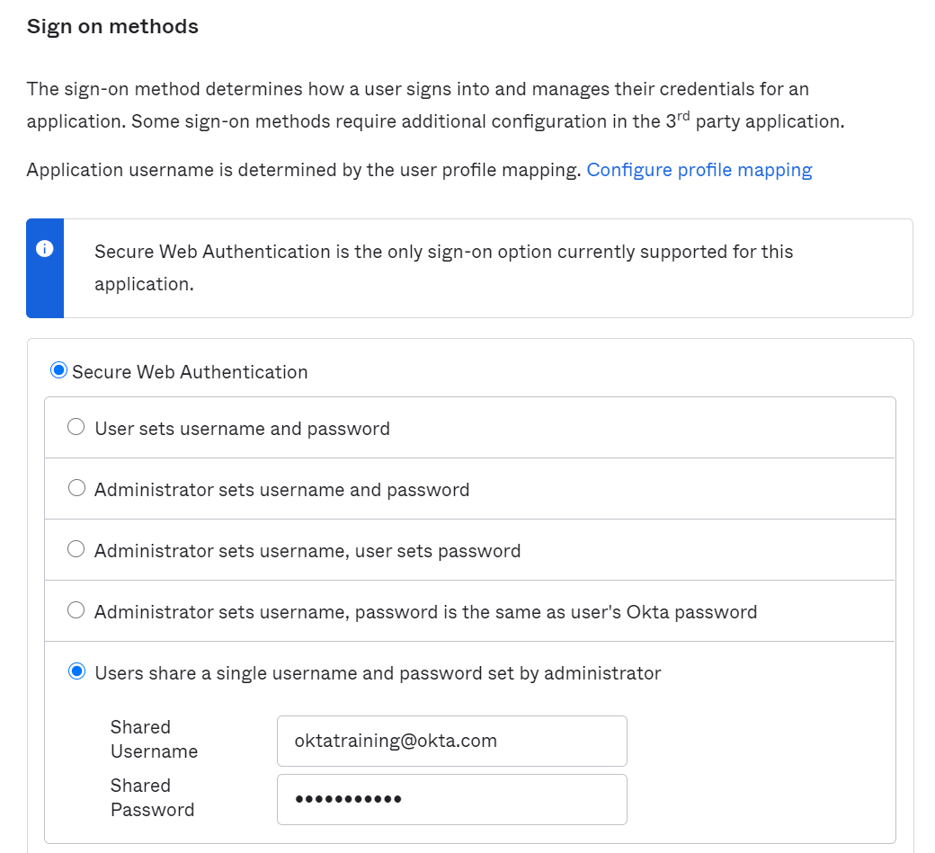
   4. Click **Done**.

### Add an App Note

1. In the application configuration page, click the **General** tab.
2. Click **Edit** in the App Settings section.
3. Type a note into the **Application notes** **for end users** text box.   
   For example, “This app, Okta Ice: Gourmet Ice Cream - Secret Recipes, should be used with discretion. DO NOT SHARE RECIPES! “.
4. Click **Save**.

### Assign the Application

1. Click the **Assignments** tab.
2. To associate all current and future members of the Management team to the Okta Ice: Gourmet Ice Cream – Secret Recipes application, click the **Assign** drop-down and then select **Assign to Groups**.  
   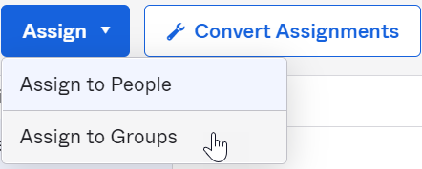
3. In the Assign Okta Ice: Gourmet Ice Cream – Secret Recipes to Groups dialog box, perform the following:
   1. In the Searchfield, type **management**.
   2. Next to the **Management** group entry click **Assign**.
   3. Click **Done**.
4. Log out of the admin account.

### Test the Okta Ice: Gourmet Ice Cream SSO

1. To test the configuration of and authentication to Okta Ice: Gourmet Ice Cream – Secret Recipes, log into your Okta org as Michael Black:  
   **Username: michael.black**  
   **Password: Tra!nme4321**
2. Complete prompted items to create the account and login.
3. Depending on your browser setup:

* You might need to install Okta Browser Plugin  
  or
* If you already have the plugin installed, you will need to grant trust to the browser so your account can easily access the apps with this browser.

**Note:** You can follow the in-app instructions to complete the above tasks.

1. Once you have the browser plugin installed, on the dashboard, click the **Okta Ice: Gourmet Ice Cream – Secret Recipes** app.
2. Verify Okta Ice: Gourmet Ice Cream – Secret Recipes successfully logs you in successfully.
3. Log out of the Michael Black account.

## Lab 5-2: Configure SAML SSO for Salesforce

|  |  |
| --- | --- |
| **Objective** | Configure IdP-initiated and SP-initiated SAML SSO for Salesforce |
| **Scenario** | Ana Walters is in the sales group and already had an account in Salesforce before Okta Ice deployed the Okta Identity Cloud service. The integration of Salesforce with Okta will allow Ana to SSO into Salesforce using her Okta login credentials. |
| **Duration** | 15-20 minutes |

### Verify the User’s Account in Salesforce

1. Open a new browser tab and log in to the Salesforce sandbox by using (copy & paste) the information provided in the Salesforce section on the Credentials tab:  
   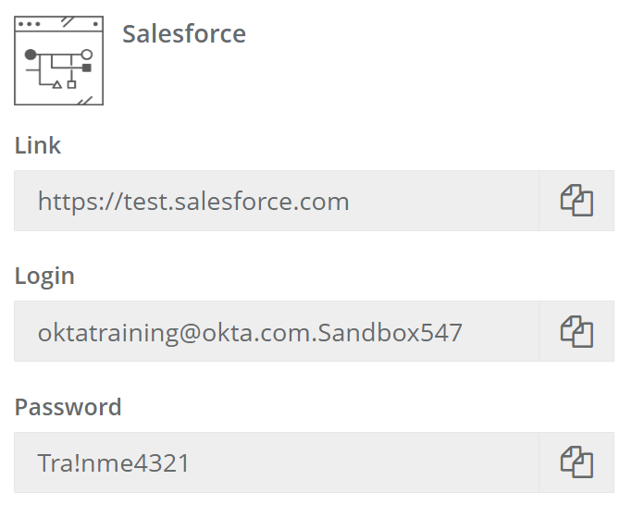
2. Once done, click **Log In to Sandbox**.
3. In the Salesforce.com console, click the gear icon in the upper right of the webpage and then select **Setup**.  
   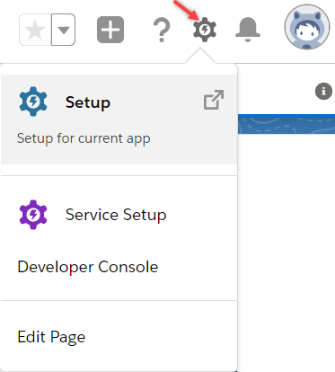
4. In the navigation pane (on the left side of the web page), navigate to **Administration**. Expand the **Users** section and click on **Users**.  
   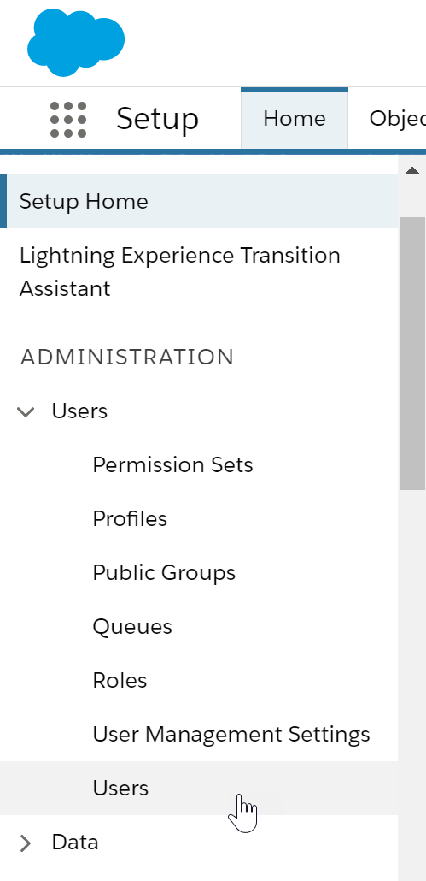

Notice there are only a few active users currently in Salesforce, Ana Walters is one of them.

1. In the navigation pane, navigate to **SETTINGS** > **Company Settings** > **My Domain**.
2. In the My Domain Settings page, locate the value for **Current My Domain URL**, note the subdomain name, which is in the format: oktaice—sandbox###. This information will be used for the configuration in your Okta org later.  
   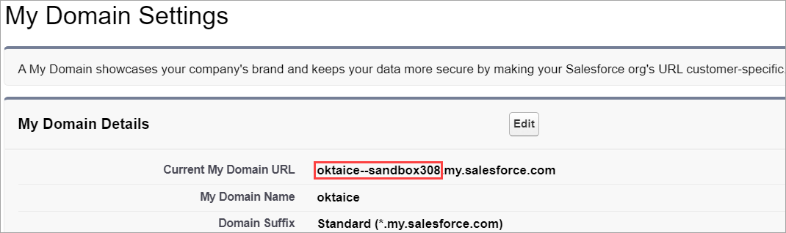

### Configure Salesforce as SP with SAML SSO

1. Log into Okta as Okta Admin.
2. In the Admin console, navigate to **Applications** > **Applications**.
3. Click **Browse App Catalog**.
4. In the **Search** field, type the key word **salesforce**.
5. Select **salesforce**.**com (**with tags of Workflow Connectors, Workflow Template etc.) from the search results.  
   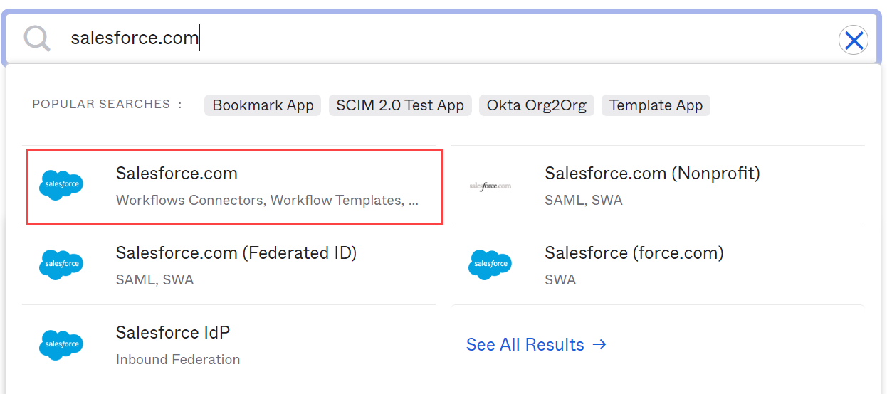
6. Review the app’s access and provisioning capabilities on the Salesforce.com page. Click **Add Integration**.  
   The Add Salesforce.com page displays.
7. On the General Settings tab:
   1. Accept the default **Application label**.
   2. From the **Instance Type** drop-down list select **Sandbox.**
   3. In the **Custom Domain** field,enter the subdomain name from Salesforce.
   4. Accept the default values for the remaining fields. Click **Next**.

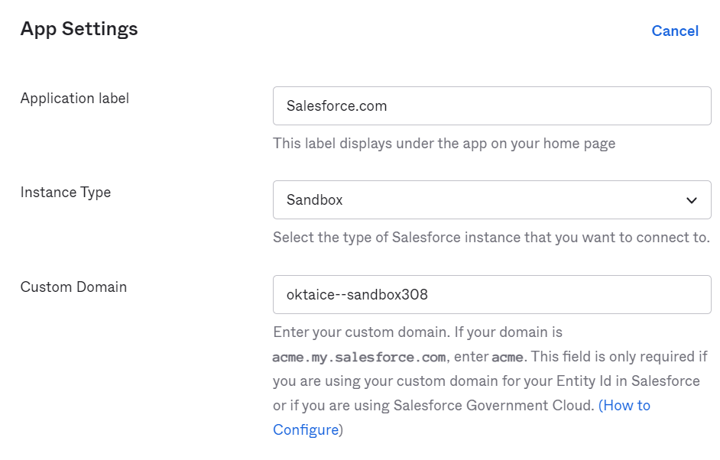

1. On the Sign-On Options tab:
   1. Click the radio button next to **SAML 2.0**.
   2. Scroll down and click **Done**.   
      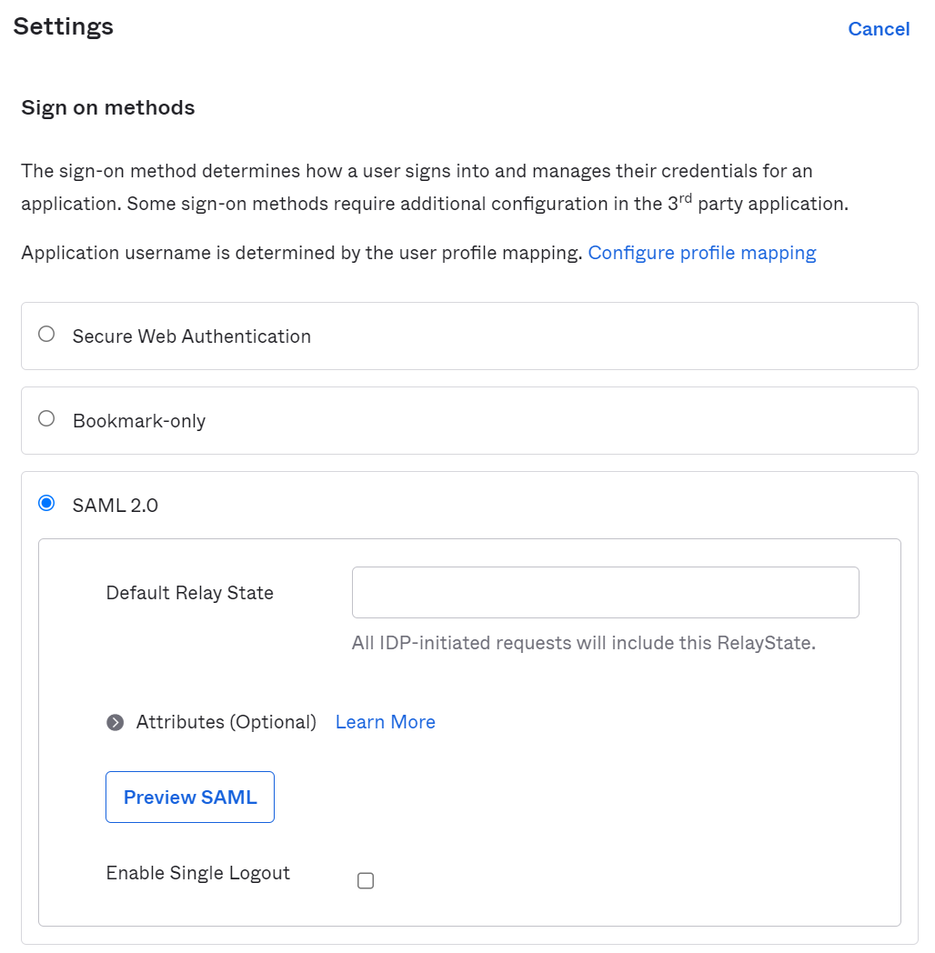

You are redirected to the Assignments tab of the Salesforce application.

1. Click the **Sign On** tab.
2. To define the username to log into the application, do the following:
   1. Next to **Settings**, click **Edit**.
   2. Scroll down to the **Credentials Details** section and change the Application username format from **Okta username** to **Custom**.
   3. In the custom string field, enter the expression below:  
      **String.substringBefore(user.email, "@") + "@oktaice*.*com.sandbox*###*"**    
      Replace *###* with the number of the sandbox assigned to you.
   4. Verify the expression by typing **Nate** and selecting Nate Abbott in the empty preview field. The result should display in a green box below (nate.abbott@oktaice.com.sandbox###)
   5. Verify Update application username on is set to **Create and Update**.
   6. Click **Save**.
3. To download the Metadata File for the Salesforce configuration, do the following:
   1. Scroll tothe **SAML Signing Certificates** section, click the **Actions** drop down menu of the active certificate and select **View IdP metadata**.  
      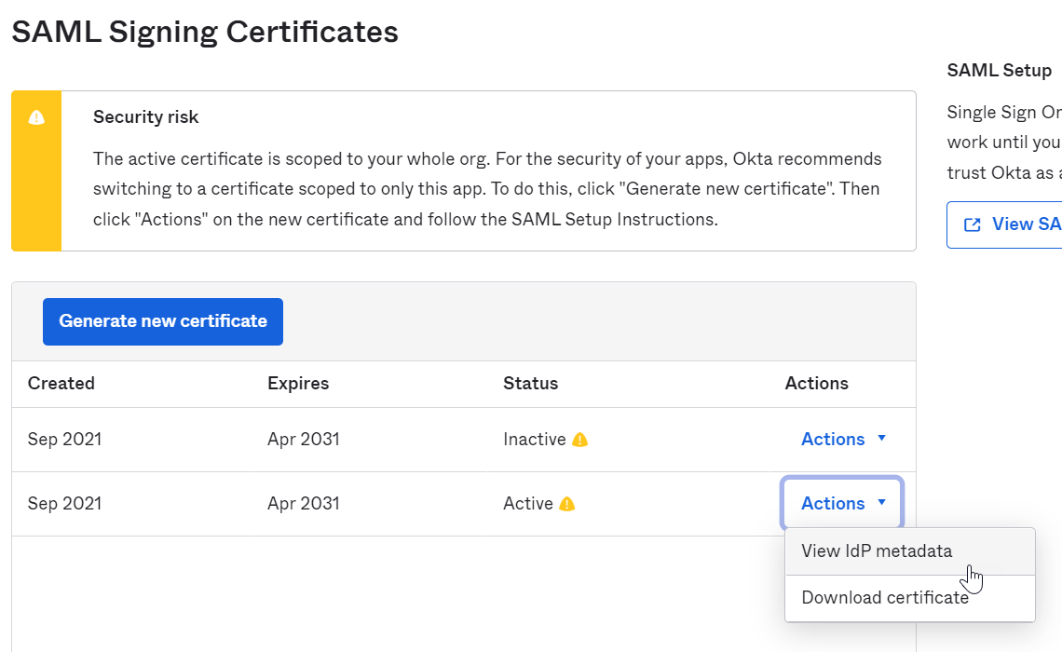  
      This will open the metadata file in a new tab page.
   2. Right-click any place in the tab page and select **Save as** from the context menu. Save the **metadata.xml** file to a folder on your computer.
4. To generate the Salesforce Login URL using the Metadata File, perform the following steps:
   1. Go to the browser tab for the Salesforce sandbox.
   2. In Salesforce admin console, click the gear icon, then select **Setup**.
   3. In the navigation pane, navigate to **SETTINGS** > **Identity** > **Single Sign-On Settings**.  
      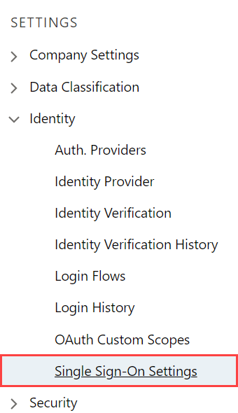
   4. On the Single Sign-On Settings page, click **Edit**.
   5. Check the **SAML Enabled** box to enable the use of SAML Single-Sign On, then click **Save**.  
      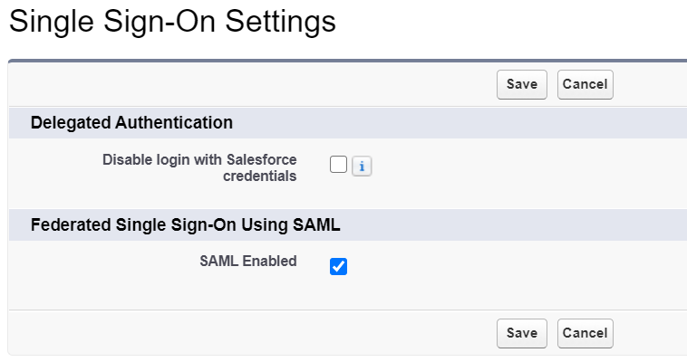
   6. You are returned to the Single Sign-On Settings page. Click **New from Metadata File**.
   7. In the SAML Single Sign-On Settings page, do the following:  
      * Click **Choose file** and select the metadata.xml file you downloaded previously.
      * Click **Create**.

The SAML Single Sign-On Settings page displays. It resembles the image below:  
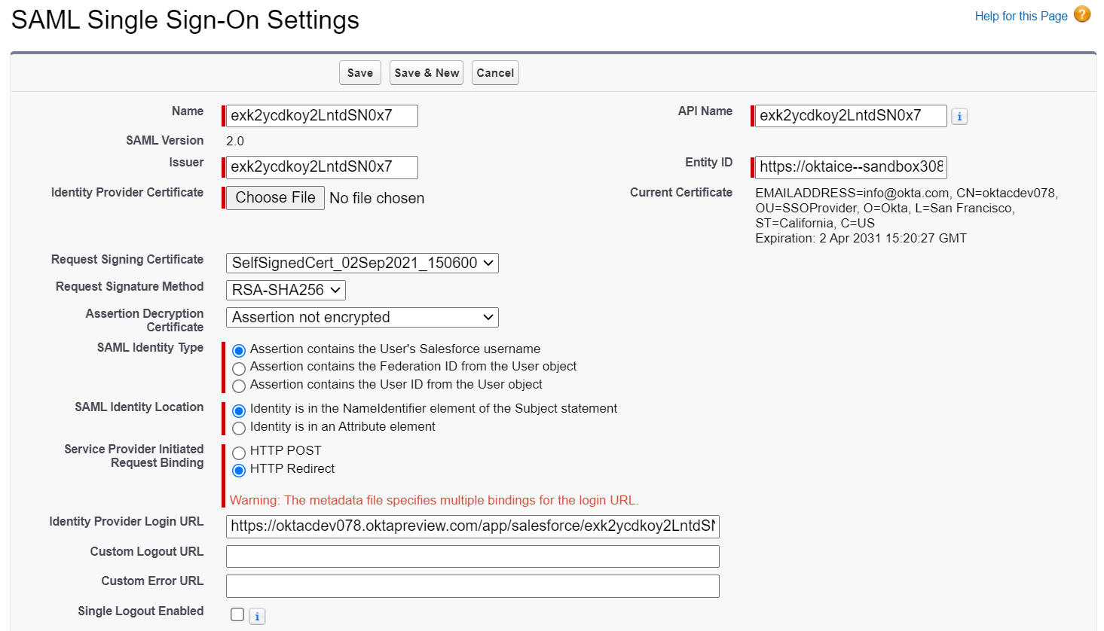  
  
You can replace **Name** and **API Name** with a more meaningful value, for example: OktaiceSAML.  
**Note:** Ignore the warning message for multiple bindings as no matter what request binding you select, the SAML response always uses HTTP POST binding.

* 1. Click **Save**.   
     The page is refreshed with a Login URL in the Endpoints section at the bottom.  
     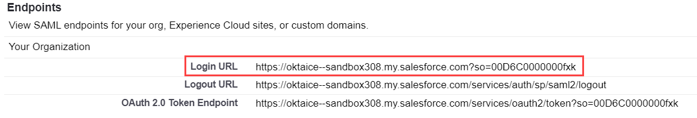
  2. Copy the Login URL value.
  3. Go back to the **Sign On** tab in the Okta admin console, click **Edit**.
  4. Scroll to Advanced Sign-on Settings and paste the value in the **Login URL** field.   
     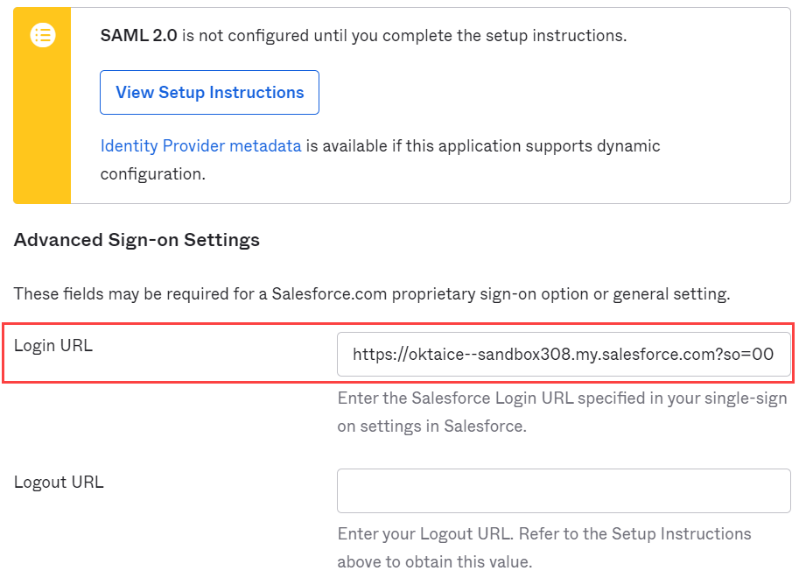  
     **Note**: Make sure the Login URL you paste in the field has **my.salesforce.com** as domain name.
  5. Click **Save.**

1. Go to **Applications** > **Applications**, you should see Salesforce.com is in the active application list.

### Assign Salesforce to the User

1. Select Salesforce.com.
2. In the Salesforce.com application page, click the **Assignments** tab and select **Assign** **> Assign to People**.
3. In the Assign Salesforce.com to People window, type “ana” in the search box. You should see Ana Walters in the search result.
4. Click **Assign**.
5. Verify the username and then click **Save and Go Back.**
6. Click **Done**. You should see Salesforce is assigned to Ana Walters.  
     
   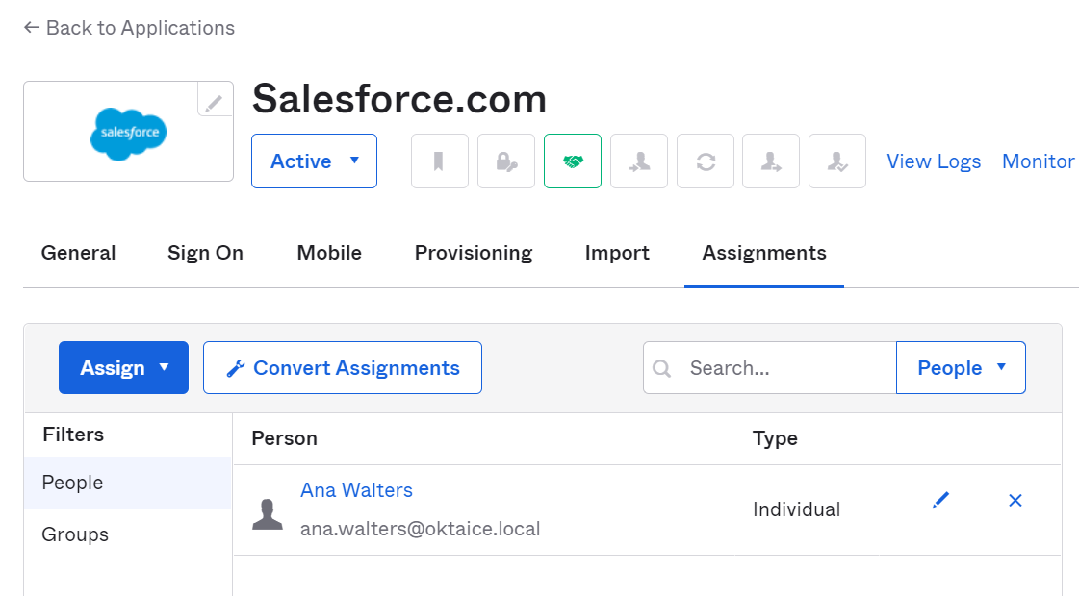
7. Log out of Okta as okta.admin.

### Verify IdP-Initiated SAML SSO

1. In the Okta Sign In page, log in with Ana Walters credentials:

* Username: ana.walters
* Password: Tra!nme4321

1. Complete prompted items to create the account and login.  
   On the End User dashboard, you should see the assigned Salesforce application.
2. Click **Salesforce**, you will automatically log into the Salesforce sandbox.  
   Now you have access to the application using one set of credentials.
3. Log out of the Ana Walters account in SFDC.
4. Go back to Okta and log out of the Ana Walters account.

### Configure SP-Initiated SAML SSO

1. Go to the browser tab for the Salesforce sandbox.
2. Log in with the Salesforce administrator credentials.
3. In the admin console, select **Setup** (the gear icon).
4. In the navigation pane, navigate to **SETTINGS** > **Company Settings** > **My Domain**.
5. Scroll down to Authentication Configuration, click **Edit**.
6. For the **Authentication Service** setting, check the box next to your okta instance SSO configuration option.   
   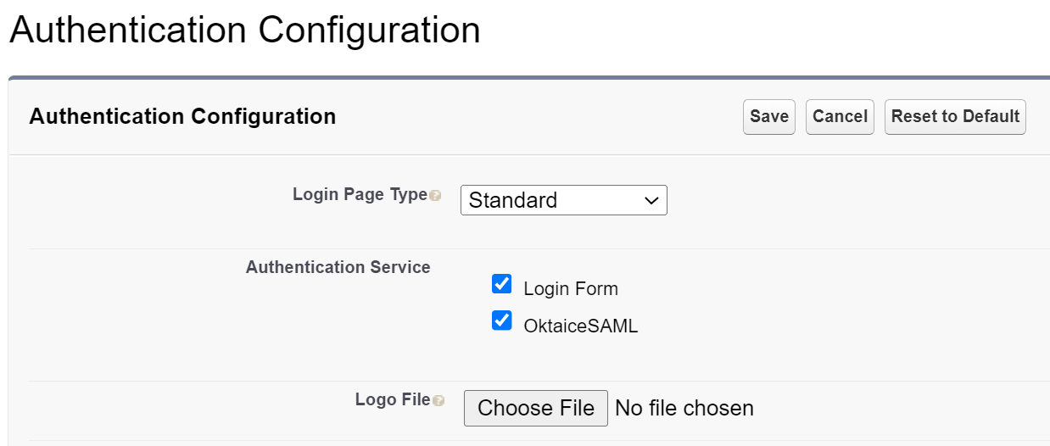
7. Click **Save**.

### Verify SP-Initiated SAML SSO

**Note:** Before performing the following task, make sure you log out of the Okta org.

1. Log out of the admin account in SFDC.  
   In the sign-on page, you should see a new login option - using your okta instance as the authentication service provider in addition to the login form you used previously.
2. Select your Okta instance for login.  
   You should be redirected to the Okta sign-on page for your org.
3. Log in with Ana Walters credentials.   
   You will automatically log into the Salesforce sandbox.
4. Log out of the Ana Walters account in SFDC.
5. Go to your Okta org and log out of the Ana Walters account.

## Lab 5-3: Add an SWA Application Using the AIW

|  |  |
| --- | --- |
| **Objective** | Add a SWA-supported application using the AIW. |
| **Scenario** | As Okta Ice begins to grow, we moved into the bakery business and acquired Barry’s Bakery. Therefore, we now have access to the Barry’s Bakery company landing page using our corporate accounts. |
| **Duration** | 5-10 minutes |

### Configure Barry’s Bakery using AIW SWA

1. Log into Okta as okta.admin.
2. Navigate to Applications > Applications, and then click **Create App Integration**.
3. In the Create a new app integrationdialog box, select **SWA - Secure Web Authentication** and click **Next**.
4. On the Create SWA Integration page, under **General App Settings**:
   1. In the **App name** field, type the following:  
      **Barry’s Bakery**
   2. In the Apps’ login page URL field, type the following: **https://bakery.oktaice.cloud/login/index.html**
   3. In the App Type field, check the box for **This is an internal application that we created**.
5. Under **How will your users sign in?**, perform the following:
6. In the Who sets the credentials list, select **Users share a single username and password set by administrator**.
7. In the **Shared username** field, type the following: **barry**
8. In the Shared password field, enter **Tra!nme4321**
9. Click **Finish**.  
   The add application wizard completes and the Admin console refreshes to the Assignments tab of the Barry’s Bakery application.
10. On the **Assignments** tab, perform the following:
    1. Select **Assign** > **Assign to People**.
    2. Select the **okta.admin@oktaice.com** account and click **Assign**.
    3. Click **Save and Go Back**.
    4. Click **Done**.

### Test the Barry’s Bakery Configuration

1. To test the configuration of and authentication to Barry’s Bakery, click the tile icon on the toolbar and select **My end user dashboard**.  
   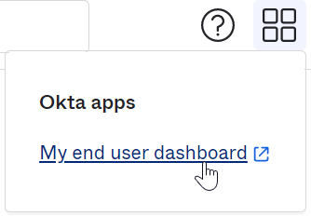
2. Grant the trust to the browser by selecting Extensions > Okta browser plugin in the Chrome toolbar.  
   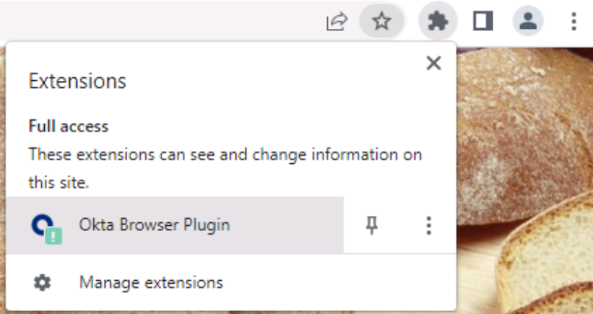
3. On the app dashboard, click the **Barry’s Bakery** app.
4. Verify Barry’s Bakery successfully logs into the account.
5. Close the Barry’s Bakery browser tab.

## Lab 5-4 (Optional): Add a SWA Application Using an Okta Template

|  |  |
| --- | --- |
| **Objective** | Add a SWA supported application using the Okta plugin template. |
| **Scenario** | After acquiring Barry’s Bakery, we realized we need a single login page for our internal employees to login. Based on the “company” they work for you can configure the login experience for each entity using the single login page. |
| **Duration** | 10-15 minutes |

**Note**: To obtain the information to add the application, perform this lab using Google Chrome.

### Integrate Okta Ice Internal using the SWA Template

1. Return to the Administrator console.
2. Navigate to Applications > Applications.
3. Click Browse App Catalog.
4. In the **search** field, type key words **template plugin**.
5. Select the **Template Plugin App 3 Fields** entry from the search result popup.
6. On the Template Plugin App 3 Fields page, click **Add**.  
   The Add Template Plugin App 3 Fields wizard displays.
7. Open a new browser tab and launch the following webpage:   
   https://internal.oktaice.cloud/
8. Return to the Okta Admin console. On the **General Settings** tab, complete the fields as follows:  
   **Note**: When you configure a Template Plugin App or Template Frame Plugin App, instead of providing the parameters, you provide CSS selectors to the relevant fields. Then at the runtime, the plugin will populate those fields and complete the login.
   1. In the Application label field, type Okta Ice Internal
   2. In the Login URL field, type https://internal.oktaice.cloud/

**Note:** In the following fields you need to determine the CSS id selectors by inspecting the individual elements on the login page of Okta Ice Internal:

* + - Username field
    - Password field
    - Extra field selector
    - Extra field value
    - Login button
  1. To locate and copy the HTML element id from the app’s login page and paste into the associated fields in the app template, perform the steps below:
     1. On the application login page, right-click the **User Name** field and click **Inspect**.  
        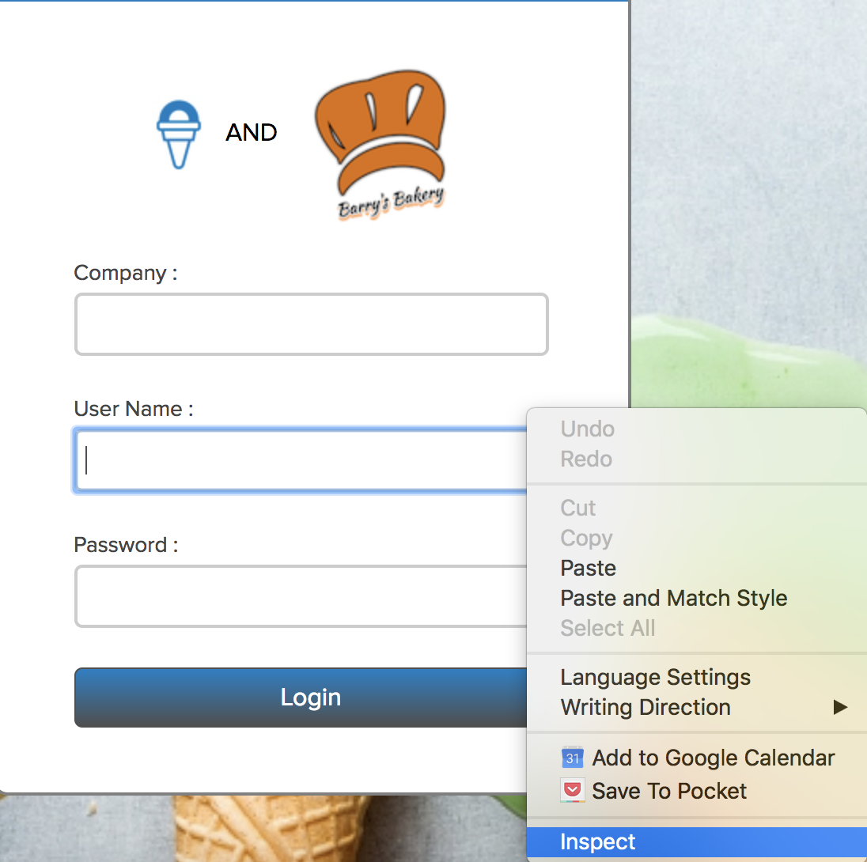
     2. In the Element pane, note the **id** of the element **UserName**, a text field, is **username**.
     3. On the Admin console, in the **UserName field**, type the id value #**username  
        Note:** For CSS selector, to select an element with a specific id, you use a hash (#) character, followed by the id of the element.
     4. Repeat steps i-iii to capture the id for element **password**, **company**, and **Login** and enter the values in the associated fields on the **General Settings** tab.
     5. In the **Extra Field Value** field, because you are assigning this app to Okta Ice employees, type the following: **OKTA**.   
        When you are done, the configuration should resemble this:  
          
        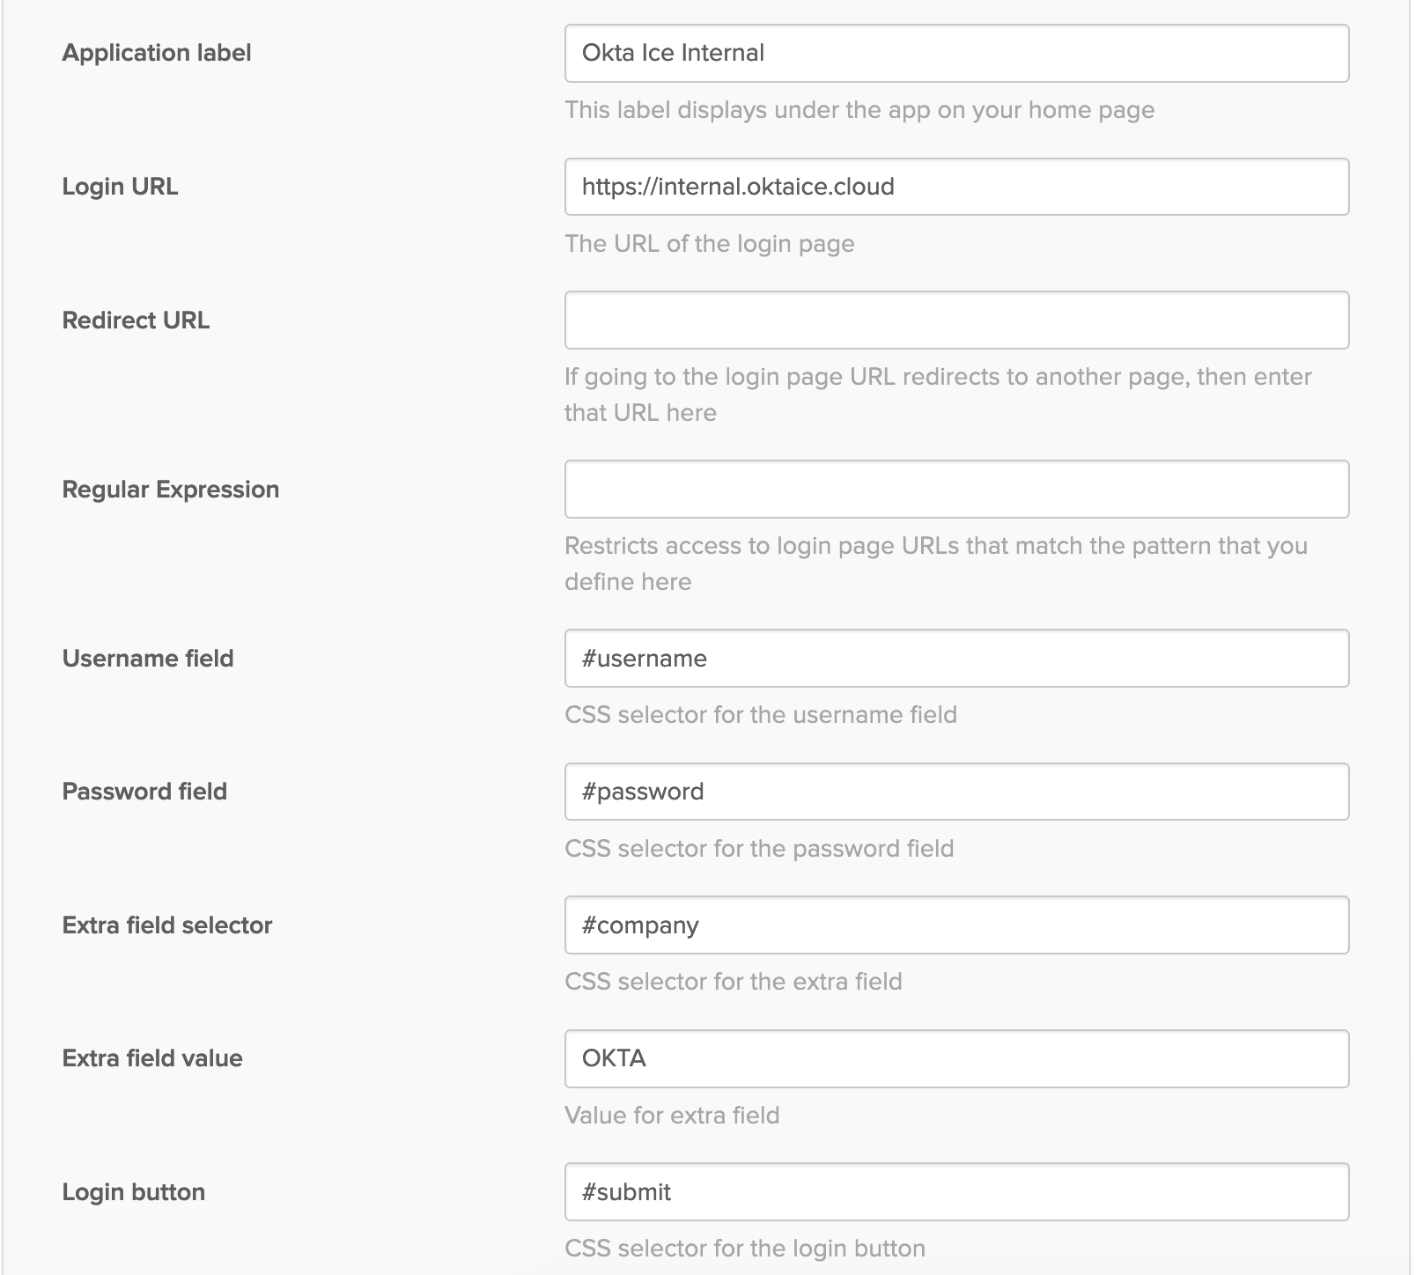
  2. Accept the default selections for the rest of the settings.
  3. Click **Next**.

1. On the **Sign-On Options** page, perform the following:
2. Select Users share a single username and password set by administrator.
3. In the Shared Username field, type the following: [**oktatraining@okta.com**](mailto:oktatraining@okta.com).
4. In the Shared Password field, enter **Tra!nme4321**.
5. Click **Done**.

The page refreshes to the Assignments tab.

1. Click **Assign** > **Assign to Groups**.
2. Search for and assign the application to the Okta and Active Directory **Sales** groups.  
   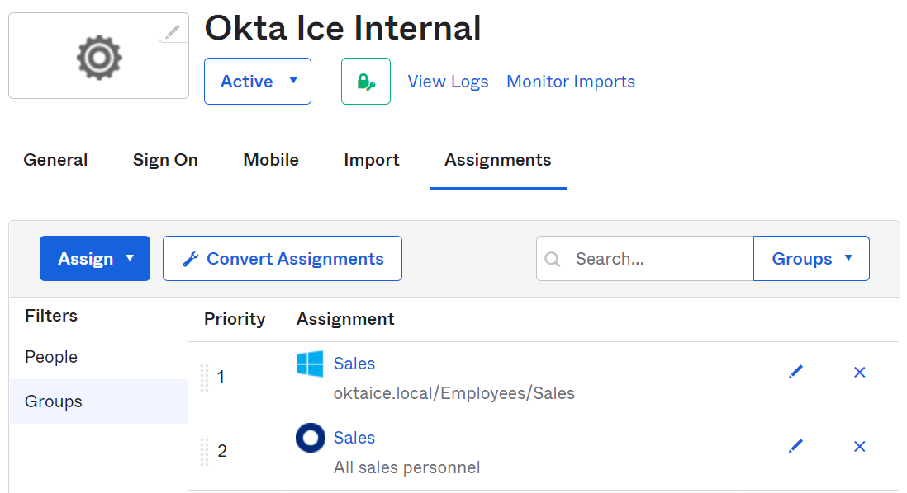

### Test the Okta Ice Internal Integration

1. To test the SSO to Okta Ice Internal, in the top-right corner of the Admin console, switch to **My end user dashboard**.
2. Click the Okta Ice Internal app.
3. Verify you can log into Okta Ice Internal successfully.
4. Close the Okta Ice Internal browser tab.

## Lab 6-1: Provision Users to SSO-enabled Application

|  |  |
| --- | --- |
| **Objective** | Enable the provisioning features of Salesforce for full user lifecycle management between Okta and Salesforce. |
| **Scenario** | After Salesforce was SSO-enabled, Okta Ice decided to purchase the user license for the whole sales group. You need to provision all the users in the group to the Salesforce app. |
| **Duration** | 15-20 minutes |

**Note:** Salesforce requires unique names for provisioning. To avoid username conflicts, Lab 5-2 included steps to create a custom username format based on the Okta expression language.

### Before You Start

Make sure:

* You have created the Okta Sales group and the Active Directory Sales group is present.
* Your Active Directory and the AD agent are running.
* The okta.admin account is created with the super admin role in your Okta org.

### Configure Provisioning in Okta

1. In the Admin console, navigate to **Application** > **Applications**.
2. Select **Salesforce.com** from the list of integrated applications.
3. On the Salesforce.com page, click the **Provisioning** tab.
4. In Settings for **Integration**, do the following:
   1. Click **Configure API integration**.
   2. Check the box next to **Enable** **API integration**.
   3. In the **Username** field, enter your Salesforce admin username provided in the Credentials tab.
   4. In the **Password + Token** field, enter the password.   
      **Note:** In the training lab environment, you don’t need to provide a token as your domain has been allowed by SFDC.
   5. Click **Test API Credentials**. If configured correctly, you should see the following confirmation message:   
      Salesforce.com was verified successfully!
   6. Click **Save**.  
      The Provisioning tab refreshes with **To App** selected under Settings.
5. To configure Okta to SFDC provisioning, do the following:
   1. In Provisioning to App, click **Edit**.
   2. Enable **Create Users**, **Update User Attributes**, **Deactivate Users**.
   3. Click **Save**.

### Assign the application to both Sales groups

1. Click the **Assignments** tab.
2. Select **Assign** > **Assign to Groups**.   
   The Assign Salesforce.com to Groups dialog box appears.
3. In the search field, type **Sales**.
4. Next to the Okta **Sales** group, click **Assign**.  
   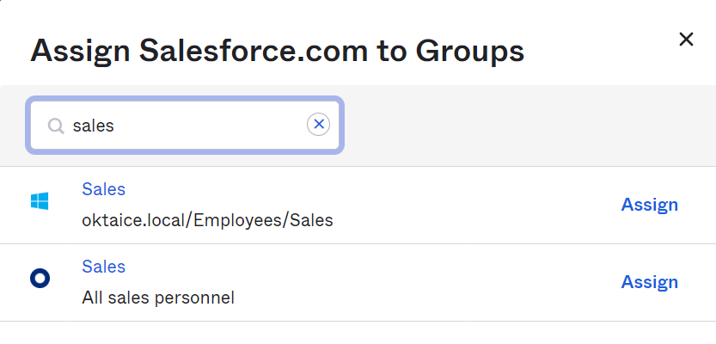
5. In the Profile list, select **Chatter Free User**.   
   **Note**: This is free profile/license we will assign to our users for testing purposes only. Normally a purchased profile/license is assigned.
6. Click **Save and Go Back**.
7. In the Assign Salesforce.com to Groups dialog box, do the same to assign the app to the Active Directory **Sales** group:
   1. Click **Assign**.
   2. In the Profile list, select **Chatter Free User**.
   3. Click **Save and Go Back**.
   4. Click **Done**.

Verify Salesforce.com is assigned to both Okta Sales group and AD Sales group.   
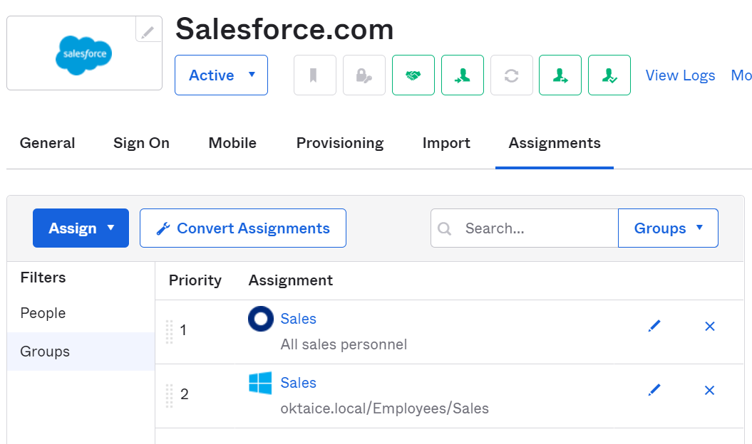

### Verify Users Provisioned in the App

1. Go to the browser tab for the Salesforce sandbox.
2. Click **Log In with a Different Account**.
3. Use the login form, log in as the administrator.
4. Click the **Setup** gear icon in the upper right of the web page.
5. In the navigation pane, expand **Administration** > **Users** and select **Users**.
6. Verify all users in Sales group are provisioned to Salesforce. They should all have a username in the format of *firstname*.*lastname*@oktaice.com.sandbox###.

**Note:** Since Ana Walters is a pre-existing user, her account is not affected by the provisioning updates.

1. Logout of Salesforce and close the browser tab.
2. Return to the Okta Admin console, go to Applications and select the Salesforce app.
3. Click the **Assignments** tab.
4. Select the **People** filter. Note that all users’ assignment type is Group except for Ana Walters.
5. Locate **Frank Molen** and select Edit to the right of his name to open the Edit User Assignment window.
6. Verify an External Id is populated with a unique identifier. This indicates that the user has been pushed successfully to Salesforce.com and there is a linkage to the account for future updates.
7. Click **Cancel** to close the window.
8. Similarly check the user assignment of **Ana Walters**. Note that she has no External Id since she was assigned to the app before Provisioning was enabled.

### Test Salesforce SSO Access using a Provisioned User

1. Log out of Okta as okta.admin.
2. Log in with the **frank.molen** credentials:

* Username: frank.molen
* Password: Tra!nme4321

1. Complete prompted items to create the account and login.
2. On the End User dashboard, click the **Salesforce** app.
3. Verify you can successfully log into the Salesforce Sandbox.
4. Sign out and close the Salesforce browser tab.
5. Log out of the Frank Molen account in Okta.

### Conclusion

Now that you have provisioned all the users in the Sales groups to Salesforce.com, you are ready to sync the attributes from the directory to the application.

## Lab 7-1: Manage Profiles

|  |  |
| --- | --- |
| **Objective** | Implement an Okta user profile with custom attributes from Active Directory that also updates Salesforce. |
| **Scenario** | Okta Ice needs to have the phone number and extension appear in Salesforce for each employee. They also want to be able to know the favorite ice cream of each employee so that they can award them on their work anniversary with a gift. |
| **Duration** | 10-15 minutes |

### Before You Start

Make sure:

* You have configured API integration between Okta and Salesforce.
* The okta.admin account is created with the super admin role in your Okta org.

### Add Custom Attributes to the Okta User Profile

1. In the Okta Admin console, log in as okta.admin.
2. Navigate to **Directory** > **Profile Editor**.
3. Under **Filters**, select **Okta**.
4. Under the Profile column, click the **User (default)** hyperlink next to Okta.  
   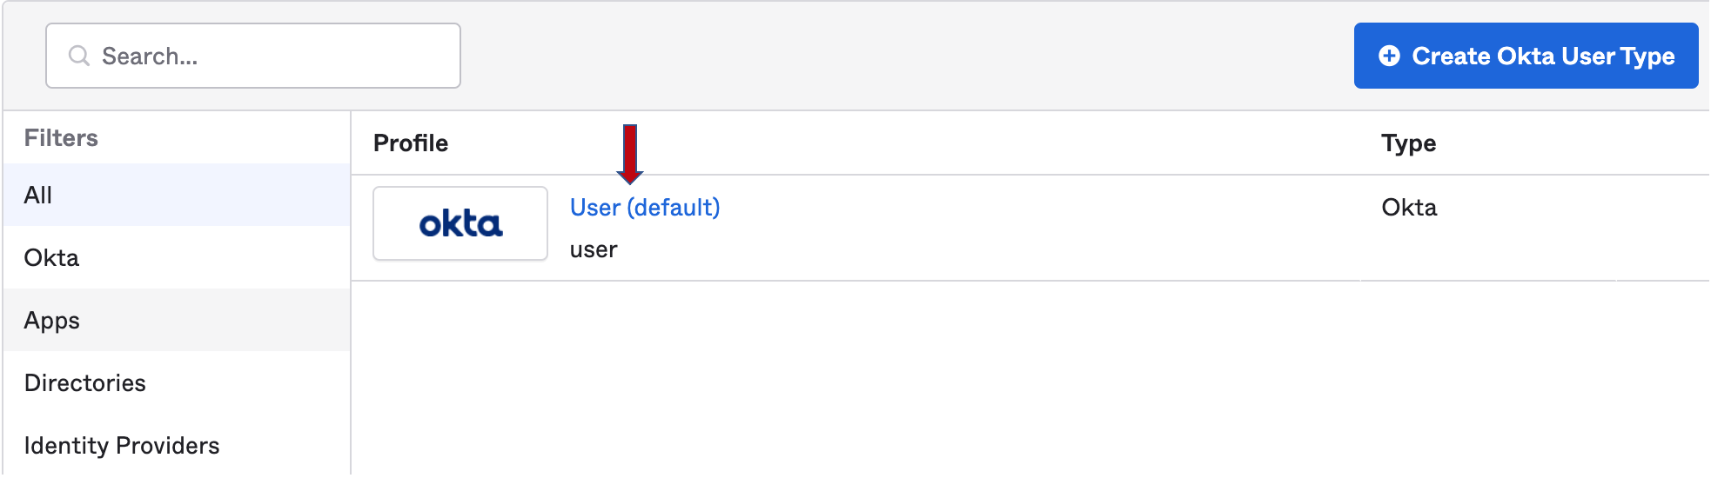
5. Under **Attributes**, click **Add Attribute**.
6. To add a custom attribute, do as follows:
7. Edit the following fields:

* Display name: **Ice Cream Flavor**
* Variable Name: **iceCreamFlavor**
* Description: **User's favorite ice cream flavor**

1. Accept the default selections or values for the rest of the settings.  
   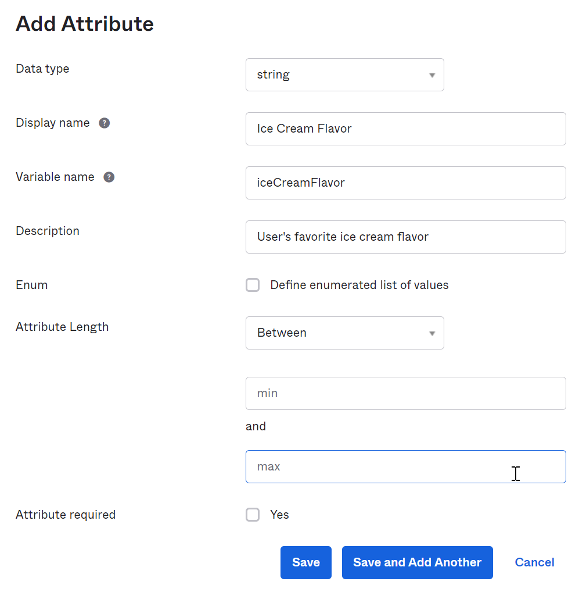
2. Click **Save and Add Another**.
3. Similarly, add another custom attribute with the following information:

* Display name: **Telephone Extension**
* Variable Name: **extension**
* Description: **Telephone Extension**

1. Accept the default selections or values for the rest of the settings. Click **Save**.

The two new attributes appear as Custom Attribute Type at the bottom of the attribute list.  
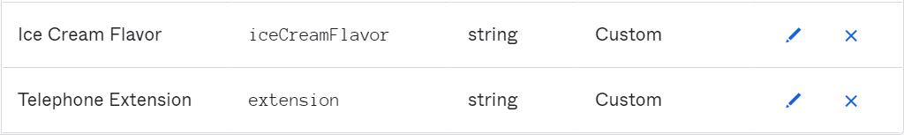

### Map Attributes from Active Directory to Okta

1. Scroll to the top of the page, click **Back to profiles**.
2. Under **Filters**, select **Directories**.
3. Next to the Active Directory user profile, click **Mappings**.  
   The AD User Profile Mappings page displays with **oktaice.local to Okta User** tab selected.
4. Scroll down the attribute list and find **iceCreamFlavor**.
5. In the **Choose an attribute or enter an expression** dropdown field for **iceCreamFlavor**, search and select **favoriteIceCreamFlavor**. (You can type ‘fav’ and then press the Tab key to enter the value.)

**Transform Phone Number and Extension from Active Directory to Okta**

1. Scroll up the attribute list and find **primaryPhone.**
2. In the **Choose an attribute or enter an expression** dropdown field for the **primaryPhone** attribute, type the following:   
   **String.substringBefore(appuser.telephoneNumber, "ext")  
   **
3. Scroll down the attribute list and find **Extension**.
4. In the **Choose an attribute or enter an expression** field for the **Extension** attribute, type the following:   
   **String.substringAfter(appuser.telephoneNumber, "ext")**



1. In the **Preview** field type **Nate** and select Nate’s name to validate your attributes are transformed correctly.

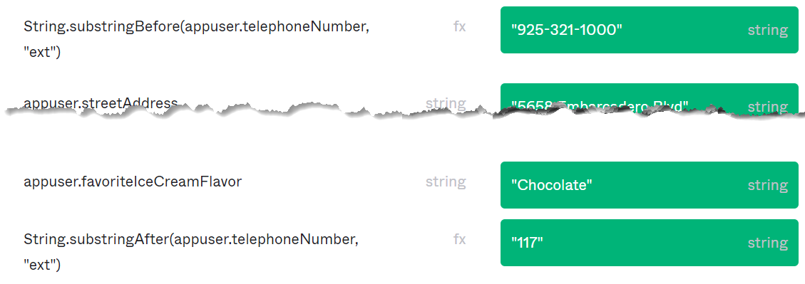

1. Click **Exit Preview.**
2. Click **Save Mappings**.
3. Click **Apply updates now**.

### Verify Mappings and Transformation

1. Navigate to **Directory** > **People**.
2. Locate and select **Nate Abbott**.
3. Click the **Profile** tab.
4. Under **Attributes**, verify the **Ice Cream Flavor** attribute has mapped to the correct field.  
   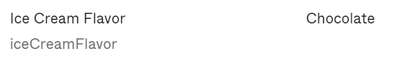
5. Under **Attributes**, verify the **Primary phone** and **Telephone Extension** attributes have mapped to the correct field.

**Note:** The format of the telephone number should be changed, displaying extension separately.

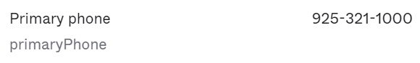

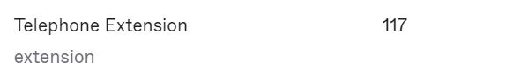

### Map Attributes from Okta to Salesforce.com

1. Navigate to **Directory** > **Profile Editor**.
2. In the Profile pane, locate the **Salesforce.com** user profile, click **Profile.**
3. Click **Add Attribute**.
4. In the **Pick Schema Attributes** window, search and then select the **Extension** attribute.
5. Click **Save.**
6. Under **Filters**, select **Custom**.  
   You should see the Extension attribute appears at the bottom of the list.
7. Click **Mappings** under Attributes.  
   The Salesforce.com User Profile Mappings page displays with Salesforce.com to Okta User tab selected.
8. Click Okta User to Salesforce.com.  
   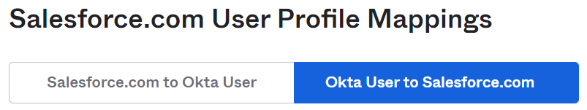
9. Scroll down the attribute list and locate the **phone** attribute**.**
10. In the Choose an attribute or enter an expression dropdown field, search and select **primaryPhone**.
11. Scroll down the attribute list and locate the **Extension** attribute.
12. In the Choose an attribute or enter an expression field for the Extension attribute, search and select **extension**.
13. In the **Preview** field type **Nate** and click on Nate’s name to validate your attributes are mapped correctly.

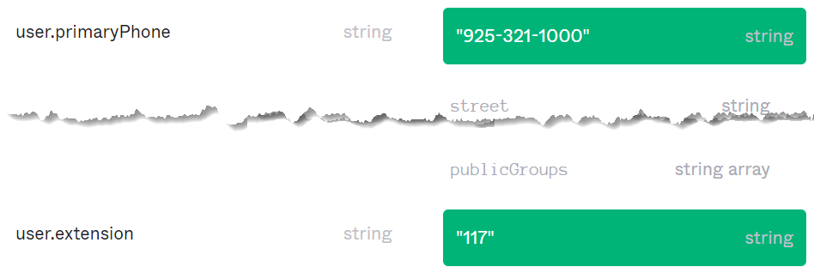

1. Click **Exit Preview**.
2. Click **Save Mappings**.
3. Click **Apply updates now**.

### Verify the Attributes in Salesforce

1. Open a new browser tab and type the Salesforce sandbox URL:  
   <https://test.salesforce.com>
2. Login as the Salesforce administrator.
3. On the Salesforce.com console, click the Setup **gear icon** in the upper right of the web page and select **Setup**.
4. Navigate to **Administration** > **Users** > **Users**.
5. Locate and click the Nate Abbott entry.
6. Verify the **Phone** and **Extension** attributes have the proper values.  
   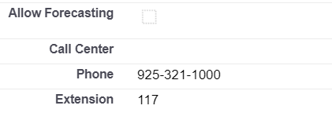

### Conclusion

Now that you have utilized Universal Directory to implement an Okta user profile with custom attributes from Active Directory that also updates Salesforce, you are now ready to explore policy-driven, contextual access management.

## Lab 8-1: Configure Okta ThreatInsight

|  |  |
| --- | --- |
| **Objective** | Enable ThreatInsight to block requests from malicious IPs |
| **Scenario** | Okta Ice want to secure their company against large scale identity attacks by leveraging the baseline security feature that Okta offers. |
| **Duration** | 5 minutes |

### Before You Start

|  |  |
| --- | --- |
| **Lab Requirement** | **Required by** |
| You have created and activated the personal account. | Lab 8-4, 8-5 |
| You have created Sales and Marketing groups in UD. | Lab 8-3, 8-4,  8-5, 8-6 |
| The okta.admin account is created with the super admin role in your Okta org. | All labs |

### Enable ThreatInsight to block malicious IPs

1. Return to the Admin console, navigate to **Security** > **General**.
2. Scroll down to the **Okta ThreatInsight Settings** section, click **Edit**.
3. Select the **Log authentication attempts from malicious IPs** option.

With this selection, any sign-in attempts from malicious IP addresses will be displayed in the system log (Reports > System Log).

1. Click **Save**.

## Lab 8-2: Setup Zones

|  |  |
| --- | --- |
| **Objective** | Create IP and Dynamic zones |
| **Scenario** | Policy configurations can affect users based on IP address and/or geographic locations. |
| **Duration** | 5-10 minutes |

### Define IP and Dynamic Zones

1. Navigate to **Security** > **Networks.**
2. Select **Add Zone > IP Zone**.
3. Define the following **Add IP Zone** settings:
   1. Zone Name**:** **Corporate Network**
   2. Gateway IPs**: 110.10.10.1**
   3. Click **Save** and verify Zone is **Active.**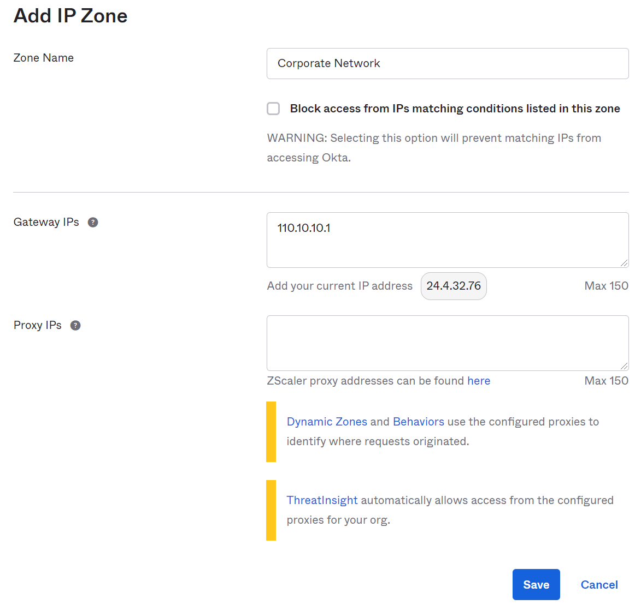
4. Select **Add Zone > Dynamic Zone**.
5. Define the following **Add Dynamic Zone** settings:
   1. Zone Name: **Restricted Countries**
   2. Define a couple countries where you currently are **not** located. You can optionally define a State or Region.

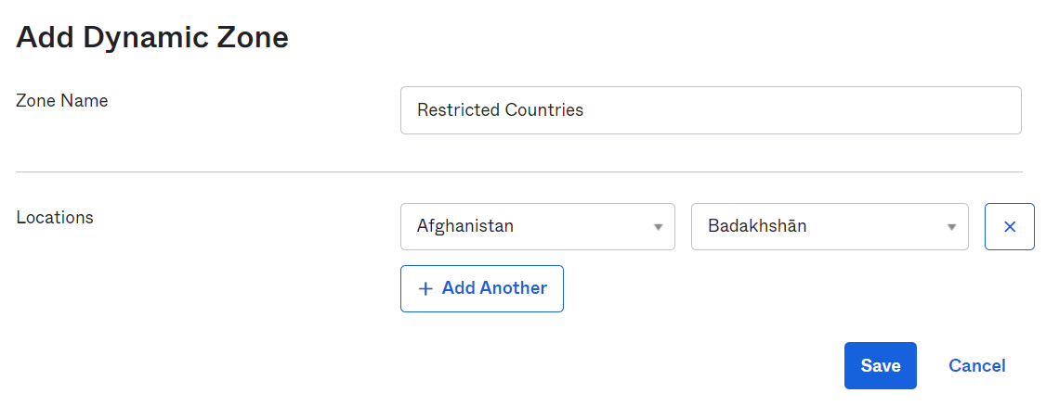

* 1. Click **Save** and verify Zone is **Active**.

## Lab 8-3: Setup a Password Policy

|  |  |
| --- | --- |
| **Objective** | Create an Okta password policy to match your company standards. |
| **Scenario** | To ensure Okta passwords for users are strong and to enhance security, we will create a password policy that leverages all of the available settings and the lockout feature will be set to a low value. |
| **Duration** | 5-10 minutes |

### Create an Okta-sourced Password Policy

1. Navigate to **Security** > **Authentication**.
2. You will land on the **Password** tab. Click **Add New Password Policy**.
3. In the **Add Policy** dialog box, perform the following:
4. In the **Policy Name** field, type the following: **Okta Accounts**.
5. In the **Policy** **description** field, type the following: **Okta-sourced user password policy**.
6. In the **Add group** field, type and select the following Okta-sourced groups: **Sales** and **Marketing**.
7. Under **Authentication Providers**, in the **Applies to** list, verify that **Okta** is selected.  
   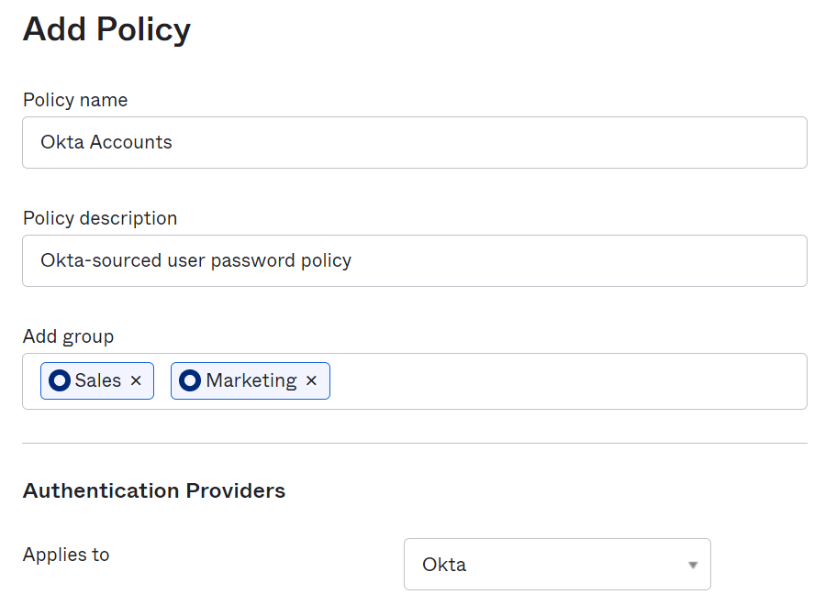
8. Under **Password Settings**, perform the following:
   * 1. Specify a **Minimum length** of **10**.
     2. Under **Complexity requirements** select **all** options.
     3. Next to **Common password check** select **Restrict use of common passwords**.
     4. Under **Password age**, select **all** options with the following values:
        + History: **5** passwords
        + Minimum age: **2 hours**
        + Password expires after **120** days
        + Prompt user **5** days before expiration
     5. Under **Lockout**, select **all** options with the following values:
        + Lock out user after **3** unsuccessful attempts.
        + Account is automatically unlocked after **5** minutes.
        + Select **Show lockout failures**.
        + Select **Sent lock out email to user**.

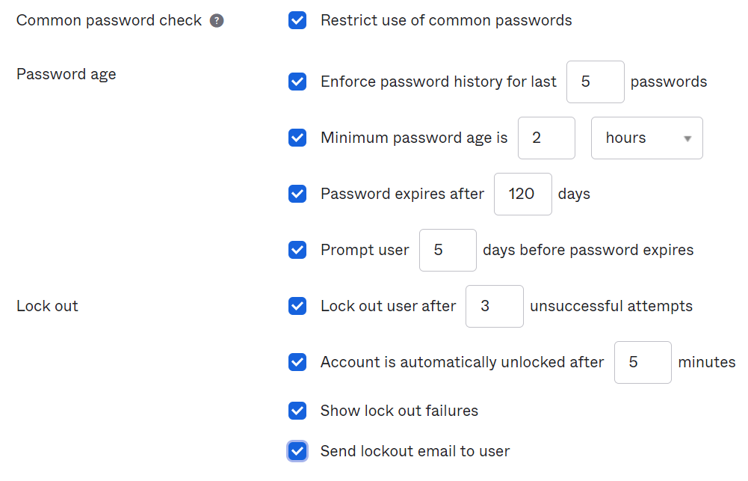

1. Under **Account Recovery**, perform the following:
2. Select both **SMS** and **Voice Call** next to Self-service recovery options.
3. For the Reset/Unlock recovery emails are valid for option, select **1 hours**.
4. In the Security answer complexity field, specify **8** characters.
5. Click **Create Policy**.  
   The Add Rule dialog box appears.
6. In the **Add Rule** dialog box, perform the following:
7. In the **Rule Name** field, type **Account Updating**.
8. Leave the **Exclude Users** field blank.
9. In the **If user’s IP is** list, select **Not in zone**.
10. Select the **Restricted Countries** zone that you set up previously.
11. Next to **The user can**, select the following options:

* change password
* perform self-service password reset
* perform self-service account unlock

1. Click **Create Rule**.

You should see the new password policy appears on the top of the policy list in the left sidebar.

## Lab 8-4: Setup MFA Enrollment

|  |  |
| --- | --- |
| **Objective** | Configure and enable MFA to match the company policies. |
| **Scenario** | To ensure that you are able to give your remote employees access to Okta and still protect their strong security policies, we will setup MFA. |
| **Duration** | 10-15 minutes |

### Select Enrollment Factors

1. Navigate to **Security** > **Multifactor**.

You will land on the Factor Types tab page with **Okta Verify** selected.

1. Click the **Inactive** dropdown button on the right and change that to **Activate**.
2. Click **Edit** and select the **Enable Push Notification** option.

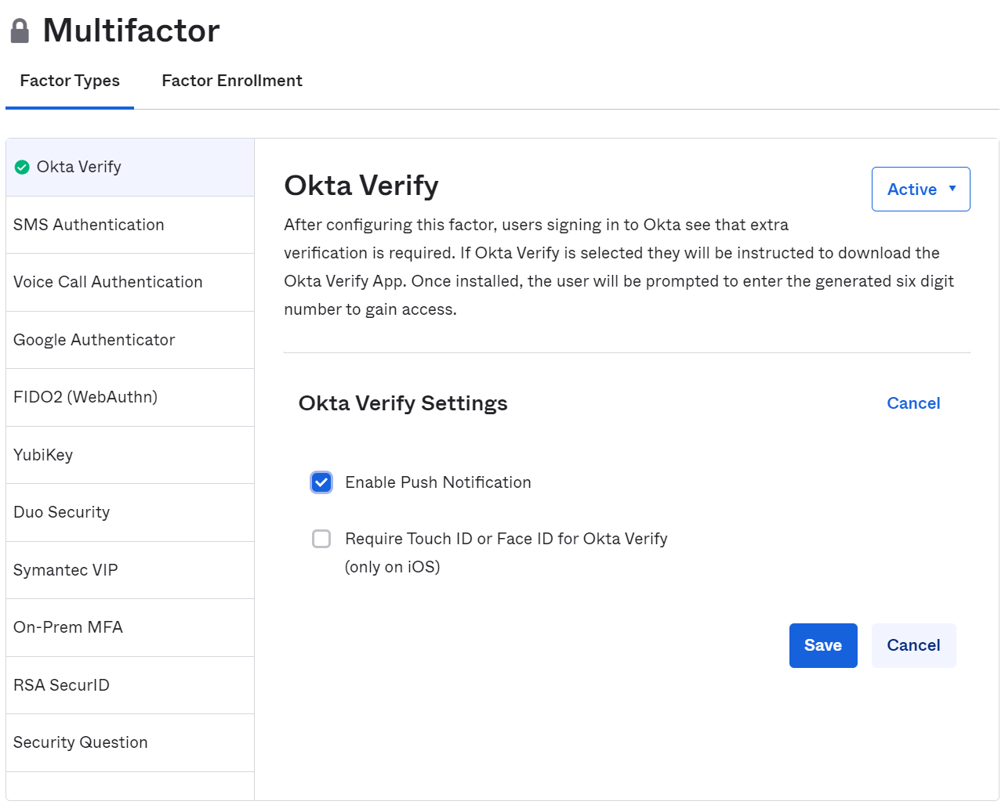

1. Click **Save.**
2. Select **SMS Authentication** and **Voice Call Authentication** and activate them respectively.

### Create an MFA Enrollment Policy

1. Select the **Factor Enrollment** tab.
2. Click **Add Multifactor Policy**.
3. In the **Add Policy** dialog box, perform the following:
   1. In the **Policy Name** field, type **Marketing MFA**.
   2. Leave the Description blank.
   3. In the **Assign to groups** field, type and select both Okta-sourced and AD-sourced **Marketing** groups.
   4. Under **Effective Factors**, select:
      * **Optional** for **Okta Verify**

Ensure the box is checked for **Okta Verify with Push.**

* + - **Required** for **SMS Authentication**
    - **Required** for **Voice Call Authentication**

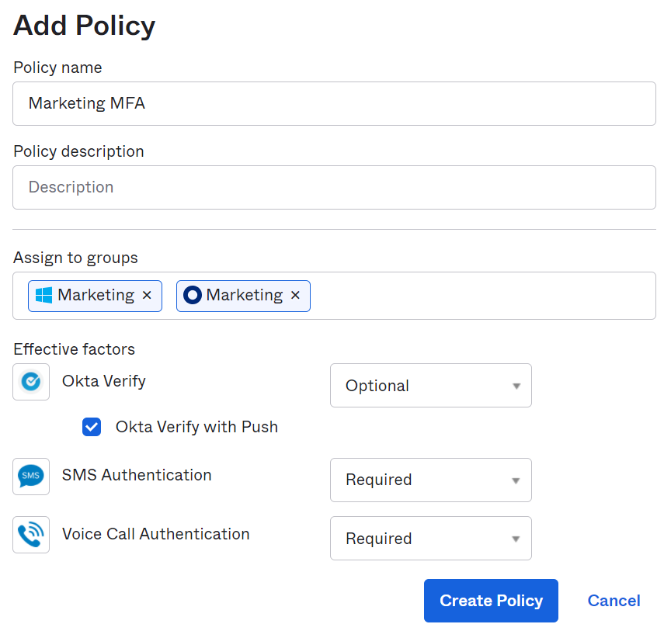

**Note:** The training orgs are not enabled to enroll into MFA for SMS or Voice Call outside of the US or Canada. If you reside overseas, set these to be optional and configure Security Question as the required factor.

* 1. Click **Create Policy**.

1. In the **Add Rule** dialog box, perform the following:
   1. In the **Rule Name** field, type **MFA Enrollment**.
   2. In the **Exclude Users** field, type and select the **Okta Admin** account.
   3. In the **If user’s IP is** list, select **Not in zone**.
   4. In the contextual field, enter and select the **Restricted Countries** zone you previously set up.
   5. In the **Enroll Multi-factor** list, select **the first time a user signs in**.
   6. Click **Create Rule**.

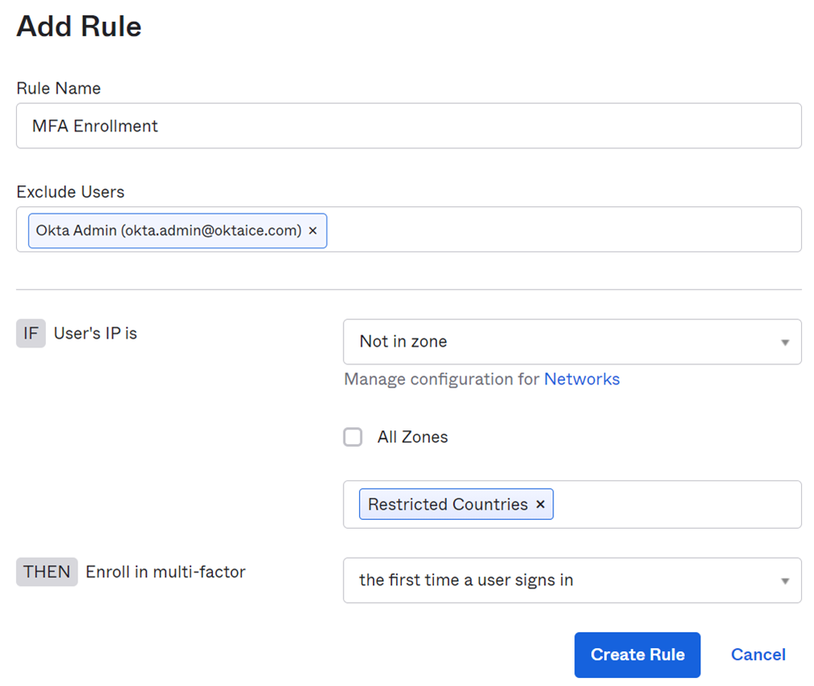

You should see the new policy added on the top of the policy list in the left sidebar.

1. Log out of the okta.admin account.

### Enroll MFA

1. Log in to Okta with your personal account credentials:
   1. **Username:** < *firstname*.*lastname* >
   2. **Password:** Tra!nme4321
2. Depending on your MFA Policy configuration:
   1. You need to configure SMS Authentication, Okta Verify, or Voice Call Authentication.
   2. Button labels change based on which factors are required or optional. The following image reflects SMS Authentication and Voice Call Authentication as required enrollment factors to be set up.  
       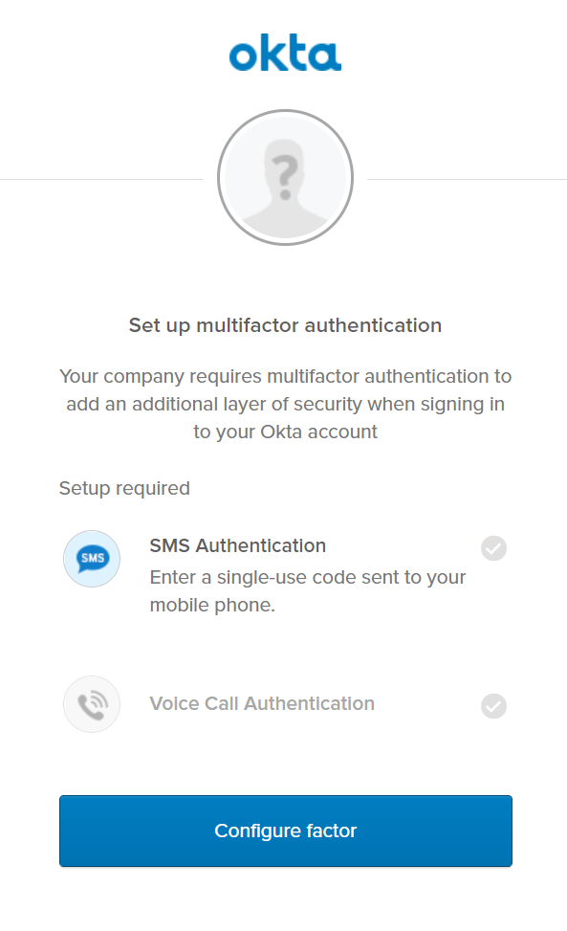
3. If you selected **SMS Authentication** as required, perform the following steps:
4. Click **Configure factor**.
5. Type your phone number and click **Send Code**.
6. Check your phone for the code.
7. On the verification page, type the code and click **Verify**. The Set up multifactor authentication page refreshes.  
   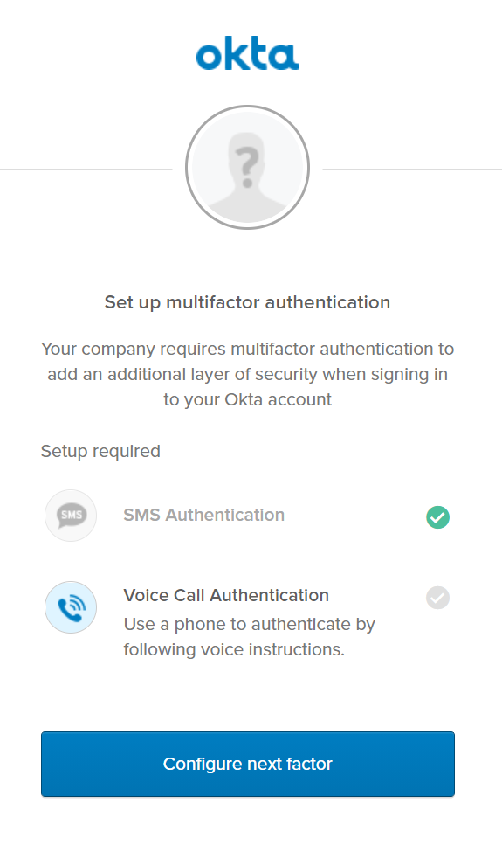
8. Click **Configure next factor** to configure Voice Call Authentication.
9. Type your phone number and click **Call**.  
   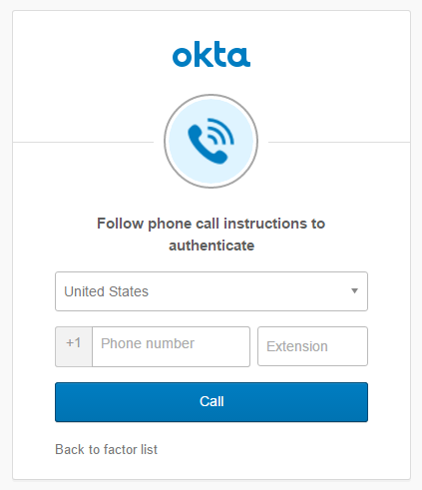
10. On the verification page, type the code and click **Verify**.

The page will refresh with the option to configure Okta Verify.

1. Click **Setup**.

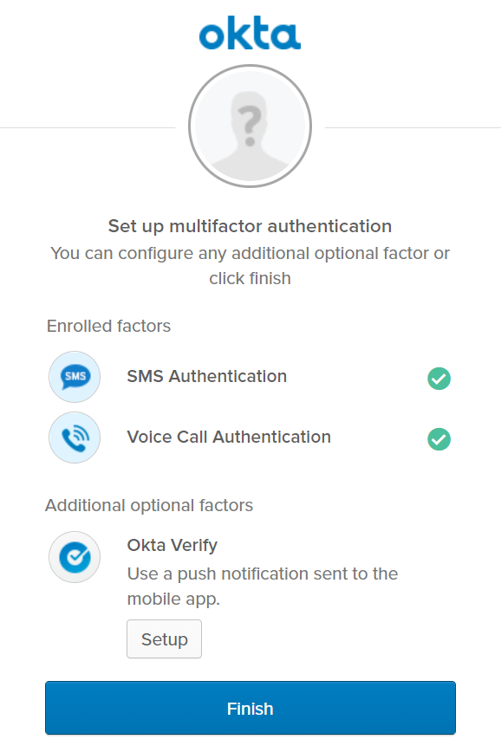

1. To configure Okta Verify, perform the following steps:
2. Select your device type and then click **Next**.  
   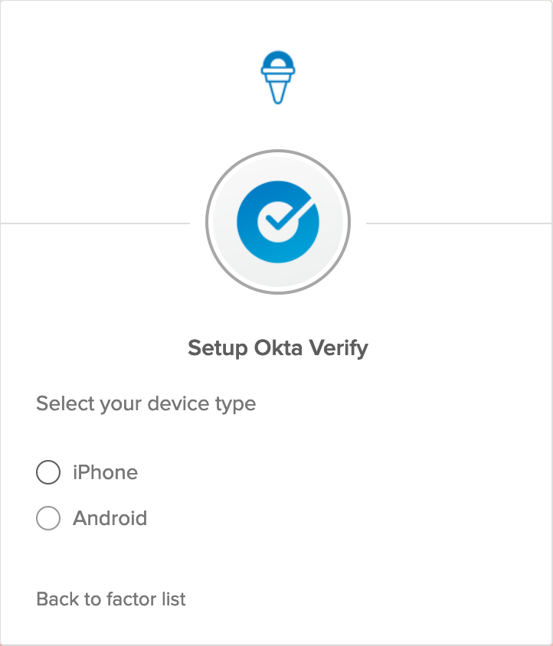
3. The dialog box will refresh with the final step to set up Okta Verify.  
   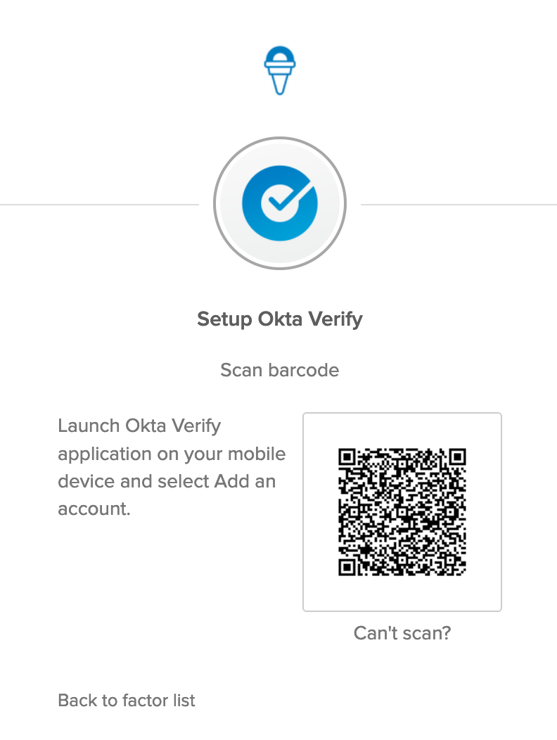
4. On your mobile device, open the app store. Search for and install **Okta Verify**.  
   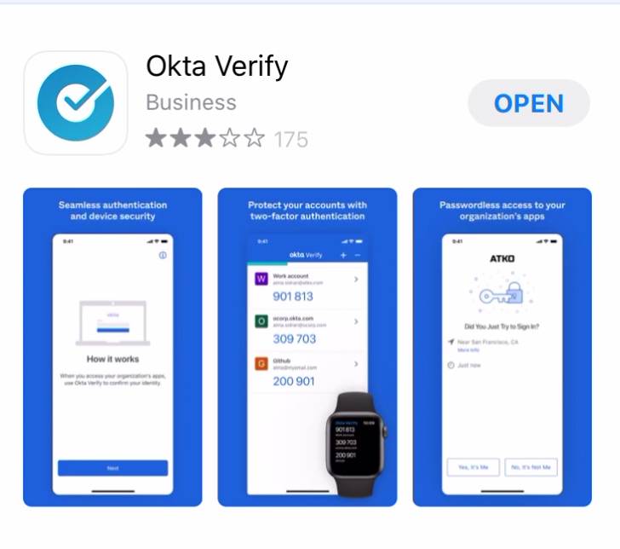
5. Once Okta Verify is installed, open the app.
6. On the home screen, click **+** icon to add a new account.
7. In the Choose Account Type step, select **Organization**.
8. In the Do You Have Your QR Code step, click **Yes, Ready to Scan.**
9. Hold your device up to the computer screen and scan the QR code.  
   You should see Account Added shortly.
10. Click **Done**. You are logged into the end-user dashboard.

At this point, you’ve completed your account MFA enrollment.

1. Log out of your personal account.
2. Log back into Okta with your personal account.   
   **Question**: This time after entering the password, are you challenged for a second factor authentication? If not, why?
3. Log out of your personal account.

## Lab 8-5: Setup an Okta Sign-on Policy

|  |  |
| --- | --- |
| **Objective** | Create an Okta sing-on policy to enforce MFA |
| **Scenario** | For employee working remotely, they need to use multi-factor authentication to log into Okta Ice org. |
| **Duration** | 5-10 minutes |

### Create an Okta sign-on policy

1. Log into your Okta org as okta.admin.
2. Navigate to **Security** > **Authentication**.
3. Select the **Sign On** tab.
4. Click **Add New Okta Sign-on Policy**.  
   The Add Policy dialog box displays.
5. In the **Policy Name** field, type **Marketing**.
6. Leave the **Description** blank.
7. In the **Assign to Groups** field, type and select both Okta-sourced and AD-sourced **Marketing** groups.
8. Click **Create Policy and Add Rule**.  
   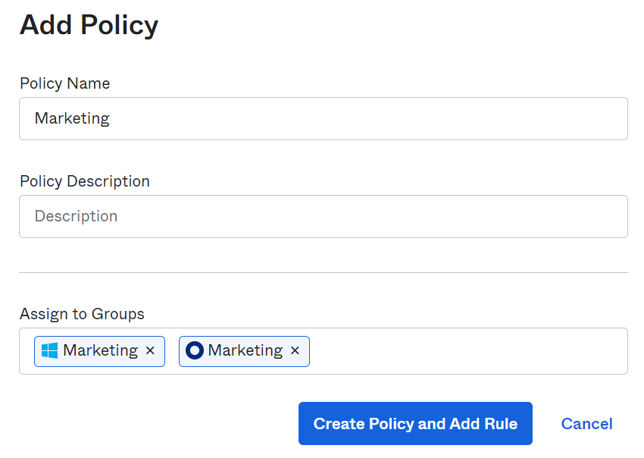
9. In the **Add Rule** dialog box, perform the following steps:
   1. In the **Rule Name** field, type **MFA**.
   2. In the **Exclude Users** field, type and select the **Okta Admin** account.
   3. Under the **IF** conditions:
      1. For user’s IP, select **Not in zone**.
      2. Type in and select **Corporate Network**.
      3. Accept the default values for the rest conditions: IdP Provider, Authentication, Behavior and Risk.
   4. Under the **THEN** actions, config as follow:
      1. Access is **Allowed**.
      2. Multifactor authentication (MFA) is **Required.**
      3. Users will be prompted for MFA: **When signing in with a new device cookie**
   5. Click **Create Rule**.

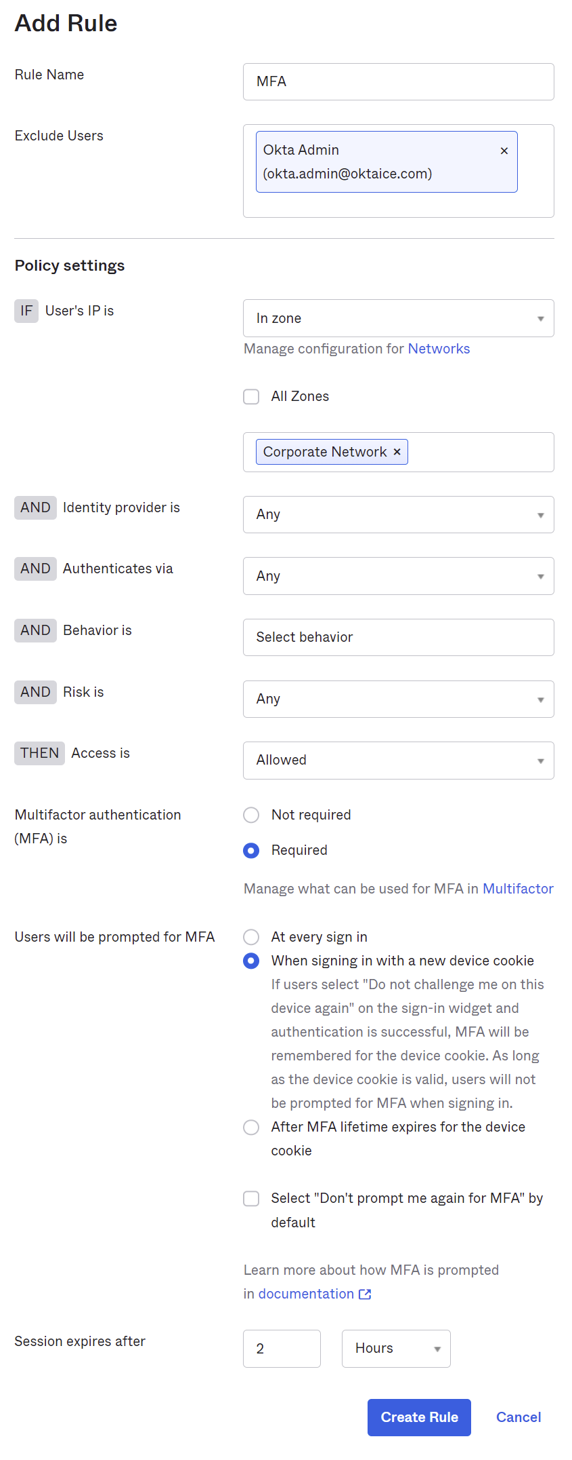  
You should see the new policy added on the top of the policy list in the left sidebar.

1. Log out of the okta.admin account.

### Sign in Okta with MFA

1. Sign into Okta with your personal account credentials.
2. When prompted for a second factor, click the drop-down button and select **SMS authentication**.  
   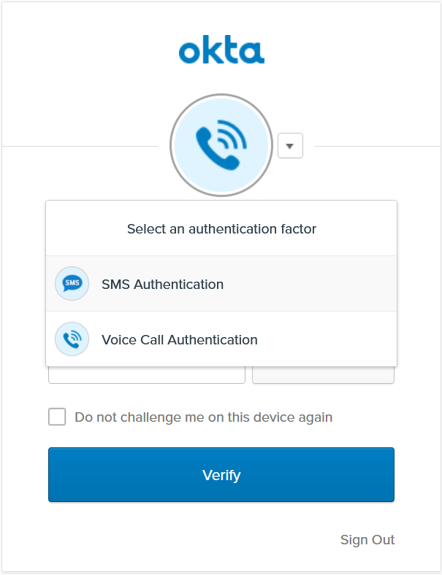
3. Click **Send code**.
4. Type the code you received on your phone and click **Verify**.

You are logged into the Okta org.

1. Log out of your personal account.

## Lab 8-6: Setup an Application Sign on Policy

|  |  |
| --- | --- |
| **Objective** | Configure an application to enforce MFA. |
| **Scenario** | When logging into Salesforce, users will be challenged to present a second factor regardless of where they are located. |
| **Duration** | 5-10 minutes |

### Create an Application Sign on Policy

1. Sign back into your Okta org as okta.admin.
2. Navigate to **Applications** > **Applications**.
3. Click the **Salesforce.com** entry.
4. Select the **Sign On** tab.
5. Scroll to the bottom of the page. Under **Sign On Policy**, click **Add Rule**.  
   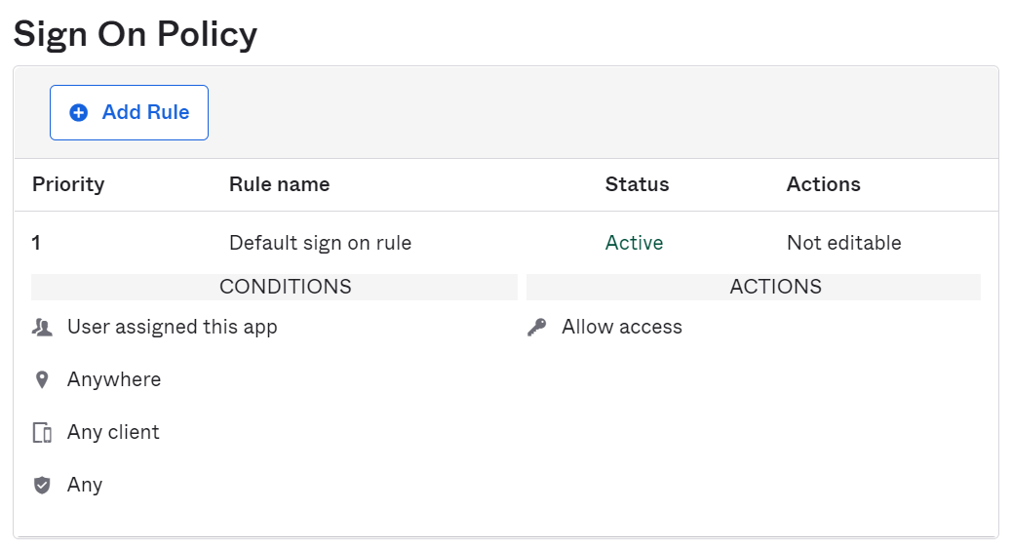
6. In the **Rule Name** field, type **MFA**.
7. Under **PEOPLE**, accept the default **Users assigned this app** selection.
8. Under **LOCATION**, accept the default **Anywhere** selection. Notice that if you select the other options this can trigger how this policy could be applied to the zones you defined earlier.
9. Accept the default settings in the **CLIENT** and **DEVICE TRUST** sections.
10. Under **Actions**, select **Prompt for factor** > **Every sign on**.  
    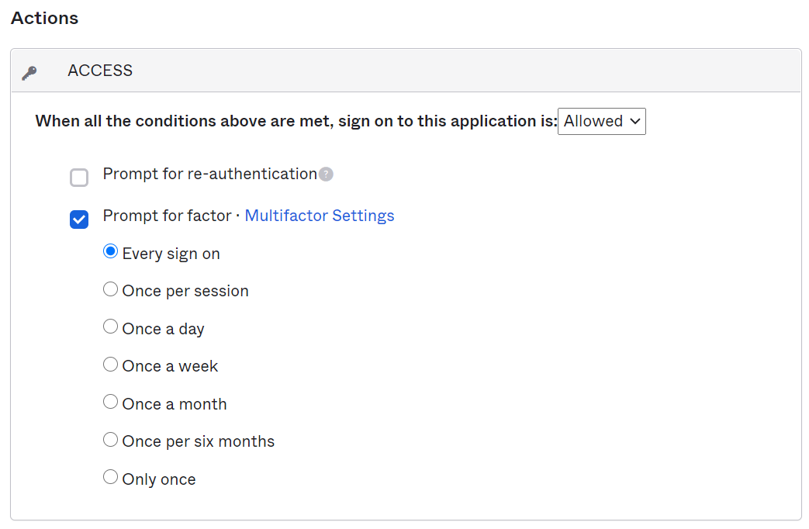
11. Click **Save**.  
    You should see the new rule - MFA is added in Sign On Policy.
12. Log out of Okta as okta.admin.

### Test the Application Sign on Policy

1. Log in as **frank.molen**
   * **Username:** frank.molen
   * **Password:** Tra!nme4321

**Question:** Why is Frank not prompted to enroll in MFA when he signs into Okta?

1. Click on the Salesforce app and you will be prompted to set up an MFA Factor.

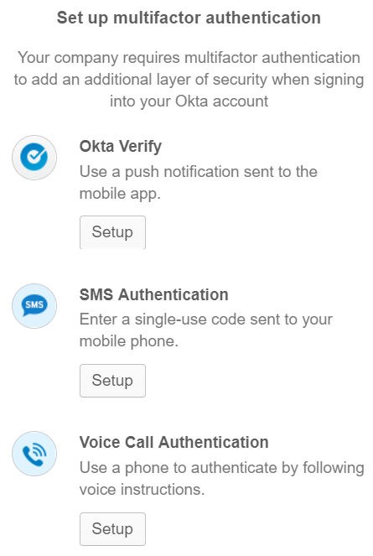

1. Select a factor and complete the enrollment setup.
2. Once the enrollment is finished, you will be prompted for the second factor to access Salesforce.com.
3. If the factor you provided is verified, you will be logged into Salesforce.com.
4. Sign out of and close the Salesforce browser tab.
5. Log out of the frank.molen account.

**Question**: If you assign Salesforce to the Okta Marketing group, and then access Salesforce with your personal account, will you be prompted to set up multifactor authentication?

### Conclusion

Now that you have created an Okta password policy and configured MFA, you are now ready to customize Okta elements such as headings, labels and the appearance of the Okta end user app.

## Lab 9-1: Customize Okta

|  |  |
| --- | --- |
| **Objective** | Customize different components of Okta to reflect your company brand and standards. |
| **Scenario** | Okta Ice wants to customize Okta to reflect the company brand and standards. We must change the colors and add our logo. We also want to replace the support contact to forward everyone to our internal wiki instead of the technical contact on the account |
| **Duration** | 5-10 minutes |

### Before You Start

Make sure the okta.admin account is created with the super admin role in your Okta org.

### Change Your Org Theme

1. Sign into Okta as okta.admin, and navigate to **Customizations** > **Branding**.
2. Change the **Primary color** and **Secondary color** with the following hexadecimal color values:

* **Primary color: #294f8e**
* **Secondary color: #abd5d9**

**Note**: The primary color is used for buttons on email templates and Okta-hosted pages, and as a navigation menu color on the End-User Dashboard. The secondary color is used as background for Okta-hosted pages and email templates.

1. Under **Logo**, click **Edit** (the pencil icon) and select **Upload new image** from the drop-down menu.

**Note**: Logos are used on email templates and Okta-hosted pages.

1. In the pop-up window, select an image on your computer.
2. Scroll down and click **Save Changes**.
3. Apply the new theme to the Okta-hosted sign-in page and the end-user dashboard.
4. In the **Okta-hosted sign-in page** pane, click **Edit.**
5. In the Style Editor view, select **Solid background** to preview your theme on the page.
6. Click **Save and publish**.
7. Go back to the Branding page, click **Edit** next to **End-User Dashboard**.
8. In the Style Editor view, select **Logo on white background** to preview your theme on the page.
9. Click **Save and publish**.

### Customize the End User Support Experience

1. Navigate to **Settings** > **Account**.
2. In the **End User Support** section click **Edit**.
3. In the **Help Link (optional)** field, type <http://wiki.oktaedu000.com>.
4. Click **Save**.

### Verify Changes

1. Log out of the admin account.
2. In the sign-in page, verify:

* The new color theme is applied to the Sign In button and the page background.
* The new corporate logo is displayed.

1. Once logged in, verify:

* The new theme is applied to the dashboard page.
* The new wiki homepage URL is in the footer of the dashboard page instead of the technical contact.

### Conclusion

Now you have customized different components of Okta to reflect your company brand and standards.

## Lab 10-1 (Optional): Monitor User Activity in Your Okta Org

|  |  |
| --- | --- |
| **Objective** | Use system log to monitor system access and user activity in your org. |
| **Scenario** | As Okta Ice administrator, you are frequently asked to provide logs related to a specific user event. The information can be used to detect suspicious activities and troubleshoot issues with user accounts. |
| **Duration** | 5-10 minutes |

### Before You Start

Make sure you have completed:

* AD integration - Provisioning users from AD to Okta
* SFDC integration - Provisioning users from Okta to Salesforce
* The okta.admin account is created with the super admin role in your Okta org.

### Examine System Log with the Pre-defined Filter

1. In the End User dashboard, click **Admin** to switch back to the Admin console.
2. Navigate to **Reports** > **Reports**.
3. Select **Application membership change** on the right from the list of System Log filters.

This will open the System Log displaying only data related to application membership change events for the past 7 days.

1. You can see the filter for Application Membership Change in the Search field:  
    eventType sw "application.user_membership"

**Note**: sw stands for Starts With.

1. Review the list of events. You will see the events include both adding and updating membership activities (shown in the **Event Info** column) in Salesforce.com and Active Directory (shown in the **Targets** column).
2. Select an event of adding a user to Salesforce.com, for example Frank Molen, and expand it to examine the event details.  
   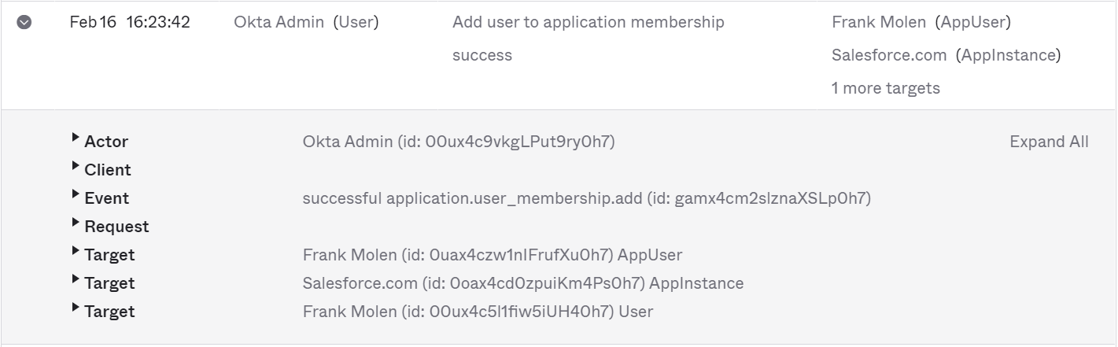

### Customize System Log with Advanced Search Criteria

Create a log filter to obtain the information about users that are added to the Salesforce.com application.

1. Click the **Advanced Filters** link under the Search field.
2. In the Advanced Search dialog box, click the filter value **application.user_membership**.
3. In the dropdown list, select **application.user_membership.add**.
4. Click **Add Filter**.
5. To add the additional criteria that will select Salesforce.com as target, do as follows:
   1. Click in the **Enter a field to filter by** field, select **target.alternateId** from the dropdown list.
   2. Accept the default operator **equals** as is.
   3. Select **Salesforce.com** for the filter value.  
      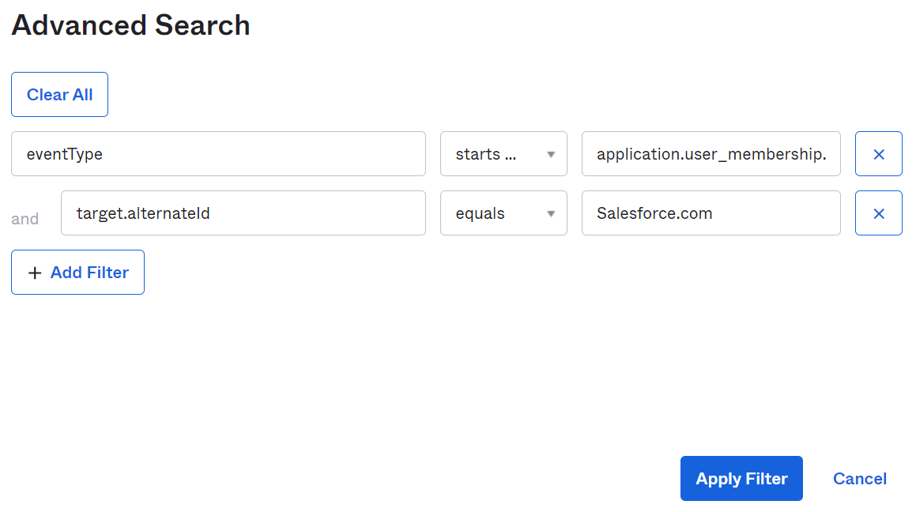

**Note:** Okta’s system logs are categorized by Okta event type. Each of these events represents a specific type of system activity, such as user creation, login attempt, etc. You can search on event types and correlate activity with other log attributes such as the event outcome, IP address, application name and browser type, etc.  
Check out this [web page](https://support.okta.com/help/s/article/Useful-System-Log-Queries?language=en_US) for some useful system log queries.

* 1. Click **Apply Filter**.

The system log page is refreshed with the events that are only adding members to salesforce.com.

### Conclusion

You can now collect and monitor your Okta logs which will give you greater visibility into access and lifecycle events for all your users and applications.

## Appendix A: Add Provisioning to User Account Created in SFDC

|  |  |
| --- | --- |
| **Objective** | Demonstrate how to leverage an API integration with an application to import existing users in bulk who need the application assignment in Okta. |
| **Scenario** | After Salesforce Provisioning was enabled, and lifecycle management events such as Create and Update have been enabled and tested, the Okta admin notices updates are not occurring for Ana Walters. |
| **Duration** | 10-15 minutes |

**Note:** Importing is one way to solve for this Provisioning related issue. An Okta Admin could remove the existing user assignment for Ana Walters and then reassign her the application in Okta, thus establishing the API integration during the new assignment. However, when this issue exists for user in bulk (perhaps hundreds or thousands) the “rip & replace” procedure is not recommended. Importing is considered the better solution in this case.

### Before You Start

Make sure you have completed Labs 5-2, 6-1 & 7-1.

### Import & Assign the Salesforce Application to an Ana Walters to Include Provisioning

1. In the Okta Admin console, navigate to **Application** > **Applications**.
2. Select **Salesforce.com** from the list of integrated applications.
3. On the **Assignments** tab, click on the **pencil icon** next to **Nate Abbott’s** name.
4. Note the **External Id** value is populated. This value is required in order to link this user account to another account in the Salesforce application; it is the link to Nate’s Salesforce assignment in Okta to his account in Salesforce.
5. Close the **Edit User Assignment** window for Nate Abbott.
6. On the **Assignments** tab, click on the **pencil icon** next to **Ana Walters’** name.
7. Note Ana Walters’ application assignment in Okta does NOT have an External Id value. Ana’s assignment in Okta is NOT linked to her account in Salesforce via the API.
8. Close the **Edit User Assignment** window for Ana Walters.
9. Click the **Import** tab.
10. Click the **Import Now** button.
11. After the import has completed, note in the “14 users scanned!” alert contains a note: **1 users removed**.
12. Click **OK**
13. Click the **Assignments** tab.
14. Note that **Ana Walters** is no longer assigned the Salesforce application. This is due to the enabled Provisioning now taking over and removing any “unrecognized” assignments; in other words it removed any users without valid External Id’s.
15. Click the **Import** tab, and then click the **Import Now** button again.
16. In the “13 users scanned!” alert, note: **1 new users imported**
17. Click **OK**
18. Note the **1 PARTIAL Okta user match found** entry for Ana Walters.
19. Click the select checkbox on the far right to selected Ana’s record.
20. Click **Confirm Assignments 1** button in the upper right corner.
21. In the “Confirm Imported User Assignments” window,click the **Auto-activate users after confirmation** check box.
22. Click **Confirm**.
23. From the **Import** tab, click the **Clear Unconfirmed Users** button.
24. In the “Clear unconfirmed users?”window, click **Clear import results**.
25. Click on the **Assignments** tab.
26. Note Ana Walters has been reassigned.
27. Click on the **pencil icon** next to **Ana Walters’** name.
28. Note that Ana Walters account now has an External Id value.
29. Close the Edit User Assignment window.

You should now be able to **Update** or **Deactivate** Ana’s account from Active Directory and see the changes reflected in Salesforce after completing an import between Okta and AD.